Humanitarian project
institution "Territorial centre of social service of the population "Warm house" (ITCSSP "Warm house»)

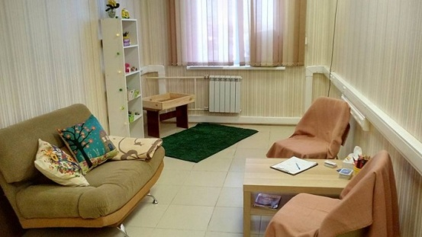 |  | 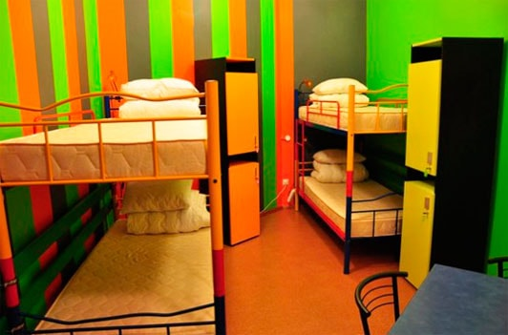

1. Project name: "Transit center for persons in crisis»
2. Project implementation period: 2 years, 24 months.
3. The applicant, the proposed project: ITCSSP "Warm house".
4. The aim of the project: to promote the development of new social services for people from socially vulnerable segments of the population through the organization of the Transit center.
5. Tasks planned for implementation within the framework of the project:
• To create a service of assistance to socially vulnerable categories of the population through the opening of the Transit centre with the provision of a places for temporary accommodation to resolve the crisis.
• To organize work to improve the skills of specialists in the social sphere to provide professional support to persons in crisis.
6. Target group: persons in crisis (victims of domestic violence, victims of natural disasters, man-made disasters, orphans and left without parental care, families in a situation of divorce, conflict, low-income persons, unemployed citizens, persons released from prison, co-dependent family members of alcoholics and drug addicts).
7. Brief description of project activities:
• Purchase of a two-room apartment for the organization of a Transit center in it and consulting specialists: repair of premises, purchase of furniture and office equipment, equipping the Transit center with interior and household items, necessities.
• Training of 2 specialists working with the crisis.
• Organization of work with the target group of the project (educational courses, psychological therapy and legal advice (individual and group) acquisition of office equipment, psychological tools and equipment, stationery, the formation of a thematic library.

8.Total funding (in US dollars)86 200
Sourceoffunding | Amount of financing (dollars USA)
sponsor funds: | 80 500
co-financing: | 5700
9. Place of project realization: | Grodno region, Smorgon, ITCSSP "Warm house»
10. Contact person: | Lyudmila Olekhno,director's assistant, tel.:8-01592-3-95-43, teplyjdom@tut.by

