Humanitarian project “Ecological and Biological Center “DAR”

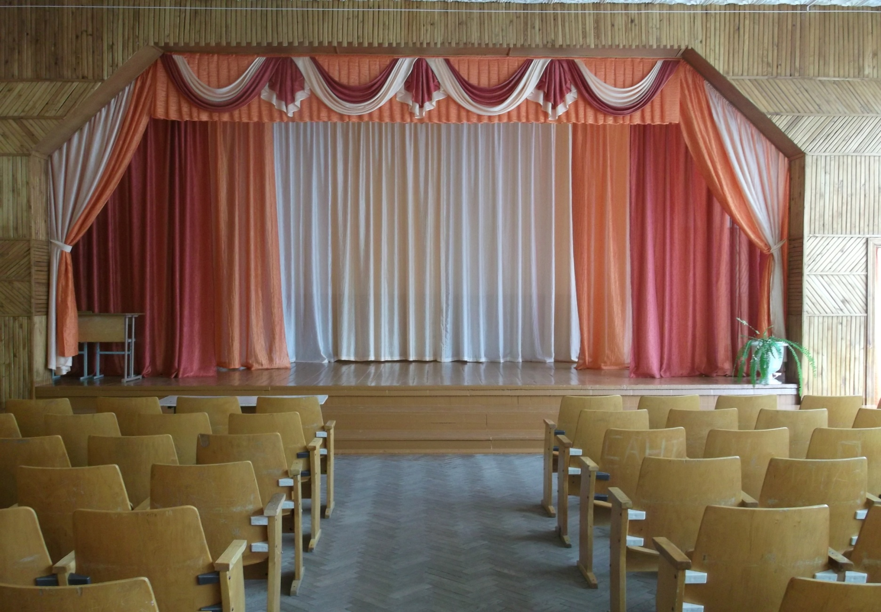 | 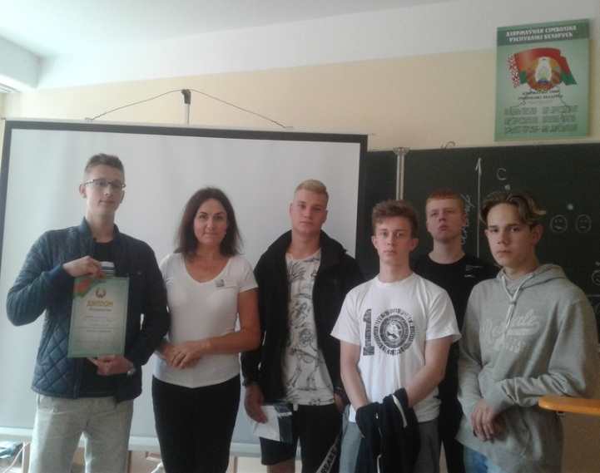

1.The working title of the project: “Ecological and Biological Center “DAR”
2. Projectimplementationperiod: 2 years
3. The applicant organization: State Educational Institution "Secondary school №23, Grodno"
4. Project goals: Preservation and development of interest in the natural heritage of Grodno through the preservation of the memory of the long-lived oaks of Grodno, including as historical monuments of the native city.
5. The objectives planned for implementation in the framework of the project:
- Creation and equipment of the ecological and biological center "DAR".
- The study of the peculiar flora of Grodno, determining the age of trees growing in the city, compiling a catalog and a map of the growth of old trees in Grodno, as well as preparing to print a brochure on this topic.
- Conducting training seminars among students and teachers of schools in the city, organizing scientific and practical activities in the school with the involvement of students of schools in the city and schools of the city from the partner country.
- Development of an ecological excursion route to the places of growth of patriarchal trees.
- Creation in the school recreation of an exhibition dedicated to patriarchal trees.
6. Target group:
• Different age groups of students of secondary schools, gymnasiums in Grodno and Grodno region and their parents.
• Pupils of senior groups of pre-school educational institutions in Grodno and Grodno region.
• Residents of the microdistrict in which school number 23 is located (Boldina St., Stroiteley Ave., BLK St., Kalinovsky St., Vrublevsky St.).
7. The main activities of the project:
- Creation of the environmental and biological center "DAR" based on the school, equipping the center with the equipment necessary for work. Preparation of the Charter, long-term development plan and work plan.
- Conducting research activities according to the plan provided for by the center.
- Compilation of a catalog and a map of the growth of old trees in Grodno, as well as preparation for printing a brochure on this topic.
- Conducting a final scientific and practical conference within the framework of the project theme and publication of a collection including reports presented at the scientific and practical conference.
- Development of an ecological excursion route to the places of growth of patriarchal trees.
- Creation in the school recreation of an exhibition dedicated to patriarchal trees.
8. Total funding (in US dollars): 60000
Sourceoffinancing | Amount of financing  (in US dollars)
Donorfunds | 54 000
Ownfunding | 6 000
9. Project location: 12B Boldina street, Grodno
10. Contact person:
Konyushkevich N. G., Director, tel. / Fax: +375-152-442-142,
e-mail: school23@mail.grodno.by

