The humanitarian project “Age is not a hindrance
for us on tour”
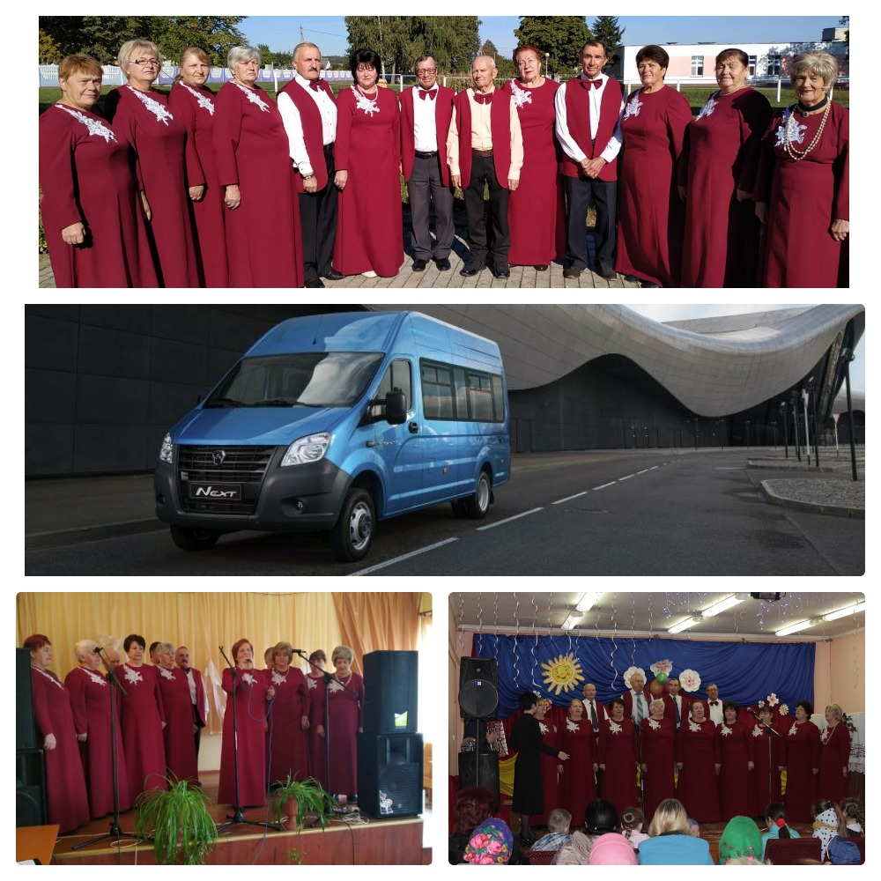
- Name of the project: “Age is not a hindrance for us on tour”
- Duration of the project: 12 months
- Applicant organization proposing the project: State Cultural Institution “Zelvensky District Center of Culture and Folk Art”
- Objectivesoftheproject:
Creating favorable conditions for increasing the life potential of older people living in the urban village of Zelva and rural areas by involving them in cultural and educational work as subjects of creative activity. Creation of conditions for the disclosure of the creative potential of people of the "golden age", improvement of their self-organization skills, involvement in the development and implementation of cultural events and projects, which will create new cultural products.
- Tasks planned for implementation in the framework of the project:
- increase the personal activity of an elderly person, maintaining his vitality;
- maintaining ties with a wide range of people;
- meeting the need for recognition;
- improvement and maintenance of the psychophysical state;
- preservation and strengthening of social activity of the individual;
- patriotic education of the younger generation.
- Targetgroup: theelderly
- Brief description of the project activities:
Creative elderly people will have the opportunity to conduct active touring and sightseeing events, meetings and cultural exchanges with their peers living in and around the region, broadcast rich life experiences, and promote the intangible cultural heritage.
- Purchase of a bus for touring activities;
- Acquisition of costumes for concert activities.
- Total funding (in US dollars): 42,000
Sourceoffinancing | Amount of financing (in US dollars)
Donorfunds | 37800
Co-financing | 4200
- Location of the project (region / district, city): Grodno region / urban settlement Zelva
- Contactperson:
Natalia Matveychik, Deputy Director of the State Cultural Institution “Zelvensky District Center of Culture and Folk Art”,+375156424531, natalimatvei@gmail.com

