Humanitarian project of the state cultural institution
«Zelvensky district Center of culture and folk art» «We know. Remember. Honor»
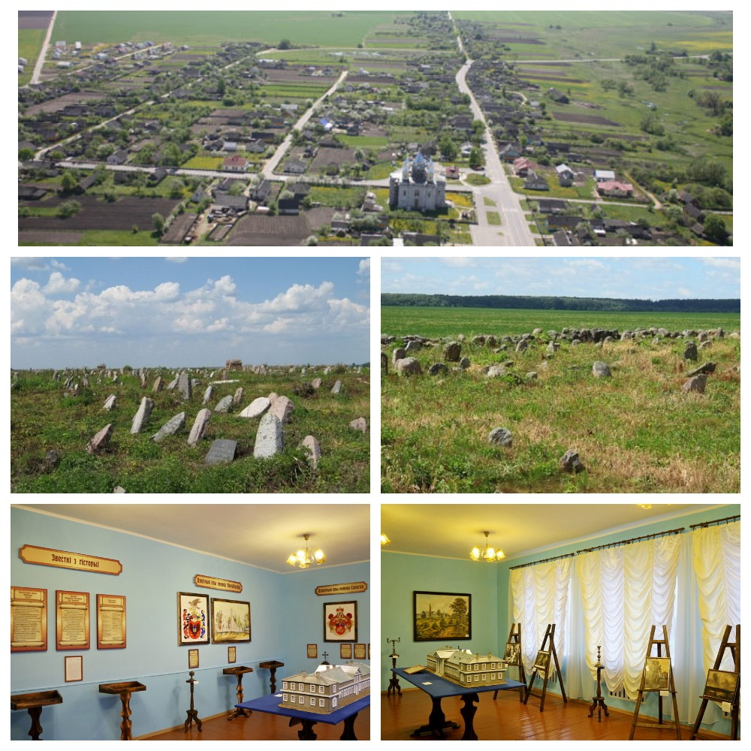

- Project name:«We know. Remember. Honor»
- The project implementation period: 18 months
- The applicant organization proposing the project: State Cultural Institution “Zelvensky District Center of Culture and Folk Art”
- Projectgoals:
- preservation of the historical and cultural heritage of the region;
- development of “necropolis” tourism;
- the preservation of Jewish cemeteries as a cultural heritage of great historical, ethnographic, artistic value;
- assistance to representatives of the Jewish community in the search for graves of ancestors on the territory of a Jewish cemetery located near the agrarian town of Derechin, Zelva District.
- Tasks planned for implementation in the framework of the project:
- implementation of research activities by scientists and historians with the involvement of the local population;
- cataloging a Jewish cemetery located near the Derechin agro-town: creating a description of the cemetery using archival information, indicating coordinates, creating a gravestone photo archive, deciphering inscriptions and epitaphs, their translation;
- creation of a database of burials and placing it freely available on the information resources of the Zelva district;
- placement of cataloged materials on the portal "Jewish roots";
- improvement of the cemetery;
- installation of tourist information boards;
- opening of the exposition devoted to Jewish culture and traditions in the museum room of the agro-town of Derechin.
- Target group: representatives of Jewish communities, researchers of Jewish culture, representatives of “necropolis” tourism
- Brief description of the project activities:
- conducting scientific and practical conferences on the topic of Jewish culture and its historical significance for the study area;
- implementation of research activities involving representatives of the Jewish community, specialists with reading skills on gravestones from Belarus and Russia, researchers of Jewish ethnography and epigraphy, historians, volunteers;
- decoding of inscriptions and epitaphs, translation into Russian;
- photographing gravestones and graves;
- entering information about the graves with their coordinates, photographic images in the database;
- on the basis of the database, the creation of a cemetery catalog, its placement in the public domain on information resources;
- development of a tourist route for representatives of Jewish communities and other tourists who wish to visit the cemetery as an object of “necropolis tourism”;
- implementation of measures for the improvement of the cemetery;
- installation of tourist information boards;
- opening of the exposition in the museum room of the Derechin agro-town,
dedicated to Jewish culture and traditions.
- Total amount of financing (in US dollars): 41200
Sourceoffinancing | Amount of financing (in US dollars)
Donorfunds | 37080
Co-financing | 4120
- Location of the project (region/district, city): Grodno region/Zelva district, Derechin
- Contactperson:
Natalia Matveychik, deputy director of the state cultural institution "Zelva district center of culture and folk art", +375156424531, natalimatvei@gmail.com

