Humanitarian project“Peaceful Atom”

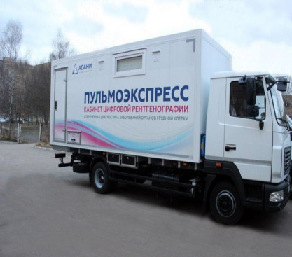 |  | 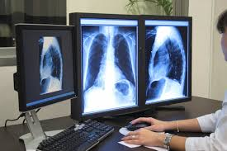
1. Name of the project:“Peaceful Atom”
2. Duration of the project:24 months
3. Organization - applicant, proposing a project:
State Healthcare Institution “City Polyclinic N 4 of Grodno”
4.The objectives of the project:Performing mobile screening and diagnostic tests of OGKs, the rural population, people undergoing routine examinations at enterprises (in the field).
5.Tasks planned for implementation during of the project:
- purchase of a mobile, mobile, X-ray diagnostic complex PULMOEXPRESS
- procurement of X-ray protective equipment for staff and patients
- X-ray room staff training
6. Target group: patients living in the area, in a remote area, persons undergoing preventive examinations at enterprises.
7. A summary of the project's activities:
1. Purchase of a mobile, mobile, X-ray diagnostic complex PULMOEXPRESS and X-ray protective equipment for staff and patients.
2. Training of personnel of the X-ray room in continuing education courses with the development of skills on this equipment.
3. Creation of a common archival database of patients.
8. Total funding (in US dollars):$ 250,000
Sourceoffinancing | Amount of financing(in US dollars)
Donorfunds | 250 000
Co-financing | 0
9. Location of the project (region / district, city):230009, Grodno region Grodno, st.Vrublevsky, 46/1, State Healthcare Institution “City Polyclinic N 4 of Grodno”
10. Contact person:radiologist (head) of the X-ray room of the City Polyclinic No. 4 of Grodno, A. Miklash tel. 55-90-08 (X-ray room), gp-4@mail.grodno.by.

