The humanitarian project of the public institution of education “Volkovysk regional center of technical creativity of children and young people”
“A safe wheel”
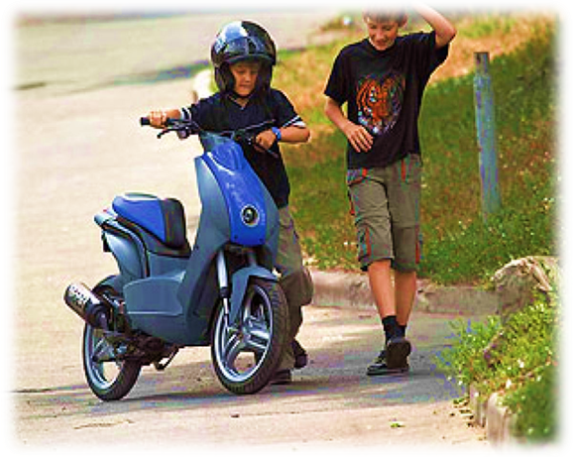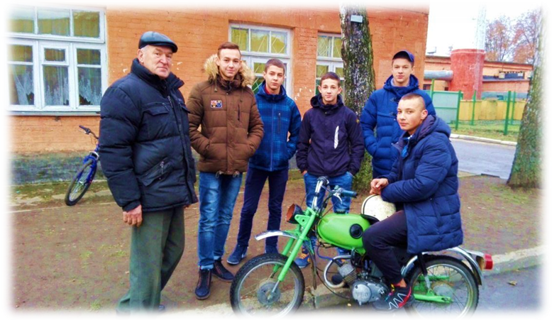

1.The title of project: “A safe wheel”
2.Terms of project:1 уеаr
3.Organization that initiates the project: the public institution of education “Volkovysk regional center of technical creativity of children and young people”
4.Aims: to organize safe free time activities for children and teenagers through teaching them traffic rules by creating an enclosed area for learning to drive motorcycles; reducing amounts of injuries among young people.
Purposes:
-ensuring the highest involvement in leisure time activities, especially for those who are in social risk groups;
-сreating a closed area for teaching children how to drive motorcycles safely;
-teaching traffic rules and specifities of perception of the situation on roads;
-forming abilities of safe behaviour in different situations on roads, developing traffic literacy of students;
-raising the sense of responsibility for students’ behaviour on roads;
-forming reasonable usage of students’ free time;
-equipping a laboratory and creating an enclosed area to learn driving;
5.Target group: 8-11 th grade students
6.A short description of events during the project:
1. Conducting a widespread advertising campaign (publishing information booklets, placing information in the press, the Internet etc.) in case to attract students into the public institution of education “Volkovysk regional center of technical creativity of children and young people”.
2. Conducting of monitoring and finding preferable companies which produce scooters, motorbikes.
3. Purchasing license disks with traffic rules.
4. Purchasing and delivery of 6 scooters and 6 motorbikes, expense parts for their servicing.
5. Holding a seminar for teachers.
6. Visiting the Centre of traffic safety, it is at the public educational institution “The Grodno Secondary School Nr. 12”.
7. Purchasing fire emergency means, first-aid kits for giving medical assistance, teaching aids.
8. The celebration of the International Children’s Day, inviting bikers.
9. The exhibition of motor transport devices of Volkovysk region, it will be held on the Driver’s Day.
10. Monitoring of children’s traffic injuries together with State Vehicle Inspection.
7. The total amount of financing (in American dollars) – 21 540,00
Financing source The amount of financing
region budget (in American dollars)
Donorfunds21 235,00
Co-financing 1 000,00
8. The place of the project realization:Zholudeva Str. 74/4, Volkovysk town, Grodno region, Republic of Belarus
9.Contact person:Lyubotynskaya Irina Fominichna, a director of studies and education, +375298677198, irina.fom@tut.by

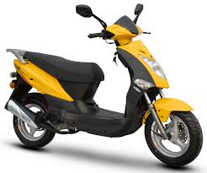

ATTACHMENT

Description of the project "Safe wheel"

In the list of causes of death from accidents, road traffic injuries firmly occupy the first line. In the Grodno region, an unfavorable situation has arisen on child traffic injuries. Analysis of children's injuries in 2018, including during the holidays, as well as as a result of road accidents, indicates the continuing relevance of the problem. In the Volkovysk district, 22 cases of minor injuries were recorded, mainly street injuries prevail. An analysis of the employment of minors showed that half of the injured children did not organize employment. In order to organize the health-saving leisure activities of children and adolescents through learning the rules of the road and reducing the number of child injuries, we decided to implement the Safe Wheel project.

The project activities will be carried out in the state educational institution “Volkovysk district center for technical children and youth” of the Grodno region. The state educational institution “Volkovyssky district center for technical children and youth” is an institution of additional education for technical children and young people, which is located in the center of the city of Volkovysk. The facility has a free adjacent territory that can be used to equip a closed area to teach children how to drive a motorcycle.

In April 2019, a general meeting of the labor collective of the State Educational Institution “Volkovysk District Technical Children and Youth Center” and a meeting of parents of students were held in order to identify personal interest and readiness to participate in the project. The result was an initiative group of teachers and parents in the amount of 12 people.

Every year the number of adherents of mototechnics increases, especially among teenagers and young people. The study of modern motorcycles, understanding of physical and chemical processes during the operation of the engine, mastering the plumbing tool during maintenance, repair, preparing a motorcycle for classes or sports competitions helps to improve the overall educational level of the child. It is clear the desire of adolescents to the technique, but to be driving motorized vehicles can be subject to a number of conditions. It is possible to drive a moped and a motorcycle upon reaching the age of 16 years. To do this, you need to study the rules of the road and get the necessary driving skills to pass the traffic police examinations for a driver's license. Mopeds, motorcycles must be registered in the traffic police and be in good technical condition. Drivers and passengers of mopeds and motorcycles must ride in motorcycle helmets.

We plan to create a club that will unite lovers of motorcycles. During the club’s classes, the children will learn the rules of safe behavior on the road, the general structure of a moped and a motorcycle, as well as test their ability to manage these vehicles, receive a full amount of knowledge of traffic rules and sustainable driving skills, maintain a motorcycle that meets the requirements. driver training category "A1", "AM". After graduation, the guys will feel confident on the roadway.

Mastering the skills of driving a motorcycle, familiarity with the rules of the road and the basics of transport safety, the ability to properly respond to the traffic situation, bringing the motorcycle management technology to perfection, as well as working out the ability to intuitively predict the development of the road situation and correct assessment is the fundamental condition for achieving high driving skills and reducing injuries.

We plan to equip an educational laboratory for theoretical and practical classes, which will comply with all sanitary and fire safety standards. The training laboratory will be provided with fire-fighting equipment, a first-aid kit for first aid, posters, instructions on labor protection.

To ensure the safety of students in driving instruction, classes will be held in a closed area. The ground for practical driving lessons should be free from various (including natural) obstacles. For safe driving motorcycles classes will be held on a specially equipped site with printed markings. We will conduct a fencing of the territory of the institution in order to prevent the entry into the territory of the institution of transport and unauthorized persons. Our partners will be traffic police officers and employees of the Grodno State Auto-Training Complex in Volkovysk.

It is in our power to make the children have a closed platform for teaching them how to drive a moped, scooter, motorcycle. A place where guys of different ages will be interesting and useful to spend time. Needless to say, minors are waiting for this site to appear. After all, children love to polish on the technique in the summer, spring and autumn! In our power to make their childhood much brighter and safer! We must help children to find something they like, help organize their health-saving leisure activities, and bring up children to be strong and resilient. We will help to give the children a happy childhood!
Organization that initiates the project: the public institution of education “Volkovysk regional center of technical creativity of children and young people”
Aims: to organize safe free time activities for children and teenagers through teaching them traffic rules by creating an enclosed area for learning to drive motorcycles; reducing amounts of injuries among young people.
Purposes:
-ensuring the highest involvement in leisure time activities, especially for those who are in social risk groups
-teaching traffic rules and specifities of perception of the situation on roads
-forming abilities of safe behaviour in different situations on roads, developing traffic literacy of students
-raising the sense of responsibility for students’ behaviour on roads
-forming reasonable usage of students’ free time
-equipping a laboratory and creating an enclosed area to learn driving
Target group: 8-11 th grade students
A short description of events during the project:
1. Conducting a widespread advertising campaign (publishing information booklets, placing information in the press, the Internet etc.) in case to attract students into the public institution of education “Volkovysk regional center of technical creativity of children and young people”.
2. Conducting of monitoring and finding preferable companies which produce scooters, motorbikes
3. Purchasing license disks with traffic rules.
4. Purchasing and delivery of 6 scooters and 6 motorbikes, expense parts for their servicing.
5. Holding a seminar for teachers.
6. Visiting the Centre of traffic safety, it is at the public educational institution “The Grodno Secondary School Nr. 12”.
7. Purchasing fire emergency means, first-aid kits for giving medical assistance, teaching aids.
8. The celebration of the International Children’s Day, inviting bikers.
9. The exhibition of motor transport devices of Volkovysk region, it will be held on the Driver’s Day.
10. Monitoring of children’s traffic injuries together with State Vehicle Inspection.

Expected results:

1. On the territory of the center there will be equipped a platform for teaching minors professional driving motorcycles.

2. In the process of training, the guys will get practical skills in the maintenance and driving of motorcycles.

3. Upon reaching the age of 16, they will be able to pass the exams at the traffic police and get driver's rights in the categories “A1”, “AM”

4. Knowing and observing traffic rules will reduce the number of road traffic injuries involving minors.

And in plans and dreams, in fact, much more than anything else.

But everything has its time. In addition, this topic worries not only us. There are not indifferent people all over the country, and little by little, a circle of like-minded people gathers. Therefore, our project is part of a big and exciting dream. Andyoucanjoinher.

PROJECT'S BUDGET
№ Budgetlinenumber | Events, goodsandservices | MiniGrantFunds (USD) | Fundsco-financed. (USD) | Totalprojectfunds (USD)
1. | Organizing and conducting a large-scale advertising campaign (producing information booklets, placing information in the press, on the Internet, etc.) with the aim of attracting adolescents to the Volkovysk Regional Center for Technical Creativity of Children and Youth
1.1. | Printing 100 pcs. informationbooklets |  | 35 | 35
1.2. | Rental of premises for events:
 | when preparing and conducting training sessions for students (1 hour - $ 10) |  | 30 | 70
 | conducting a training seminar for teachers |  | 20
 | during the organizational and informational meeting, the final round table |  | 20
2. | Acquisition of building materials, structures for improvement of a closed area
2.1 | Purchase of metal fencing and installation of fencing | 2000 |  | 2525
2.2 | Arrangement of training grounds | 500
2.3 | Marking | 25
3. | Purchase of motorcycles, consumables for maintenance
3.1 | Purchase of 6 mopeds x 1000 $; | 6000 |  | 15900
3.2 | Purchase of 6 motorcycles x $ 1450; | 8700
3.3 | Buying helmets 6 pieces | 300
3.4 | Purchase of fuel and lubricants |  | 100
4 | Registration of motorcycles in the traffic police | 300
4.1 | Passing inspection in the traffic police | 500
4.2 | Laboratoryequipmentfortraining |  |  | 110
4.3 | Purchase educational posters. |  | 20
4.4 | Purchase of fire extinguishing equipment | 30
4.5 | Purchase of first aid kits for first aid | 10
4.6 | Purchase of licensed discs | 50
5. | Volunteer activities and organization issues in the framework of the project:
5.1. | Territory preparation (cleaning, cutting, dressing, leveling) (1 share) |  | 10 | 70
5.2. | Transportation costs (visit to the road safety center) |  | 60
6. | Finalprojectactivities
6.1. | Organization and holding of a round table with the final presentation of the project results (Monitoring of cases of children's road traffic injuries in some way with the traffic police) |  | 10 | 10
7. | Transportation costs for the implementation of project activities (scooters, mopeds, motorcycles, structures):
7.1. | Rent a truck for the delivery of motorcycles | 300 |  | 300
7.2. | Payment for bank services (12 months. X 10 $) | 120 |  | 120
8. | Project staff remuneration:  project coordinator - $ 100 per month x12 months  assistant coordinator - $ 50 per month x 12 months.  Accountant - $ 50 per month x 24 months.  (including taxes and other deductions in accordance with the legislation of the Republic of Belarus) | 1200  600  600 |  | 2400
Total (USD): |  | 21235 | 305 | 21540

