________________№__________

OFFER
OJSC «Plant «Optic»

OJSC “Plant “Optic” is the largest optical company situated in the West of the Republic of Belarus in Lida. Founded in 1970 the plant has established a reputation as a reliable manufacturer and supplier of high quality optical parts. We are pleased to offer you our products:
Optical details

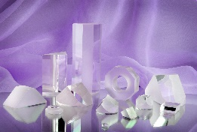
HS code: 9001900000.
Types: lenses, prisms, mirrors, plates, tubes, rods.
Technical characteristics: according to the Customer’s requirements.
Material: optical glass of various types, silica glass, water-soluble crystals, with chemical and physical coatings.
Application: medical, electronic, scientific and other devices.
Minimal quantity: 20 pcs.
Payment conditions: 100% prepayment
Fiber optic

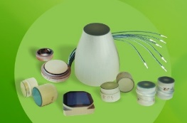

HS code: 9001900000.
Kinds of details: plates, elements, tapers, lighting bundles.
Technical characteristics: according to the Customer’s requirements.
Material: optical fiber.
Application domain: medical, electronic, military, scientific and other devices.
Minimal quantity: 5 pcs.
Payment conditions: 100% prepayment.

Laser active elements

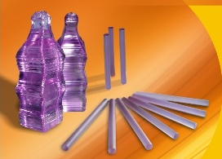
HS code: 9001900000.
Technical characteristics: dia 3-10 mm, length 80 mm according to the Customer’s requirements.
Material: single crystals KGW doped with neodymium.
Application: various laser devices and systems.
Minimal quantity: 1 pc.
Payment conditions: 100% prepayment.

Laser active elements KYW
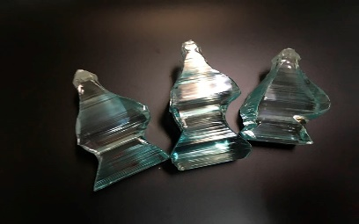

HS code: 900190000
Technical characteristics: dia. +0,0/-0,005 mm, length + 0,0/-0,10 mm according to the Customer's technical requirements.
Material: single crystals KYW doped with ytterbium ions.
Application domain: various laser devices and systems.
Minimal quantity: 1 pc.
Terms of sale: 100 % prepayment.

Medical devices:

Spectacle lenses

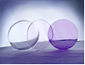
HS code: 9001404100.
Types of lenses: single vision stigmatic, single vision astigmatic, with sun-protective coating, with anti-computer coating.
Technical characteristics: refraction 0.00 − ±25.00 diopters, diameter of lens, mm: 56, 60, 65, 70.
Material: mineral optical glass БОK-3 UF.
Application: corrective eyeglasses.
Minimal quantity: 1000 pcs. Discount 5% − 20 000 pcs.
Payment conditions: 100% prepayment.

Lenses for indirect ophthalmoscopy
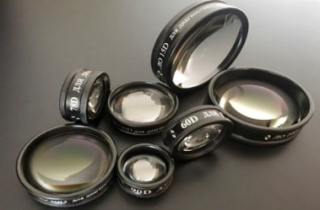

Hs code: 9018509000
Technical characteristics:
Model | Overall dimensions, mm | Clear aperture,  mm | Focal length,  mm | Max. weight,  g
LO 15D | Ø62 х 14,5 | 52 | 65,5 | 55
LO 20D | Ø58 х 16,4 | 48 | 50,5 | 52
LO 30D | Ø46 х 11 | 36 | 33,4 | 40
LO 40D | Ø42 х 11,1 | 32 | 24,9 | 35
LO 60D | Ø34 х 12 | 26 | 16,7 | 27
LO 78D | Ø34 х 14,5 | 26 | 12,9 | 33
LO 90D | Ø27 х 12,3 | 19 | 11,2 | 17
Material: single crystals KYW doped with ytterbium ions.
Application domain: are used for noncontact ophthalmoscopy of the eye ground providing a high-resolution image of the retina pattern.
Minimal quantity: 1 pc.
Terms of sale: 100 % prepayment.

Mirror ophthalmoscope OZ-2
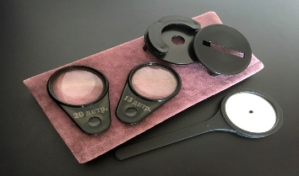
Hs code: 9018509000
Technical characteristics:
Model | Overall dimensions, mm | Clear aperture,  mm | Focal length,  mm | Diameter of the inspection hole in the center of the mirrors, mm | Weight, g
Set of mirror ophthalmoscope ОZ-2 | 160х80х30 | 43 | 175±10 | 3,5 | 200
Application domain: is used for examination of the ophthalmic fundus, cornea, moisture of the eye chambers, lens and vitreous body.
Minimal quantity: 1 pc.
Terms of sale: 100 % prepayment.

Three mirror-and for mirror ophthalmic lenses
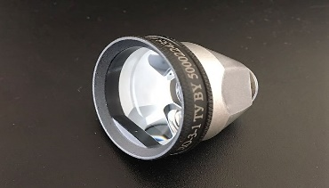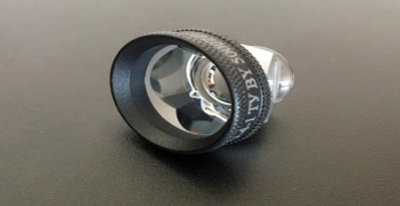

Hs code: 9018509000
Technical characteristics:
Model | Overall dimensions, mm | Clear aperture,  mm | Focal length,  mm | Incidence angle, ° | Weight, g
LO-3-1 | Ø 34,5х32,2 | 11,1; 27,5 | -15,5 | 60, 66, 76 | 37
LO-4-1 | Ø 26,5х22,9 | 11,1; 20,3 | -15,5 | 4х63 | 16
Application domain: LO-3-1 is used for visual stereoscopic study of eye ground.
LO-4-1 is used for visual stereoscopic study of angle of anterior
chamber.
Minimal quantity: 1 pc.
Terms of sale: 100 % prepayment.

Set of sciascopy frames LSK-1 and LSK-2
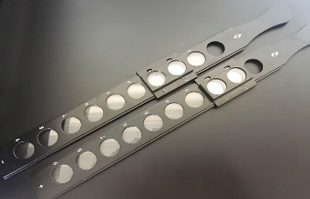

Hs code: 9018509000
Technical characteristics:
Parameter description | Value
1. Measuring range of refraction | ± 19
2.Error in refraction should not exceed values in the range, diopter:
from 1,0 incl. to 6,0 incl. | 0,12
over 6,0 to 9,0 incl. | 0,18
- for lenses of the slider :
0,25; 0,5 | 0,12
10,0 | 0,5
- or lenses of the frames in combination with the lenses of the sliders:
from 1,25 incl. to 5,75 incl. | 0,25
over 5,75 to 9,75 incl. | 0,3
over 9,75 to 18,0 incl. | 0,5
over 18,0 | 0,8
3. he acceptable value of the prismatic action arising due to the decentration,
prism diopter:

-for lenses of the frames and the sliders, diopter.
from 0,25 incl. to 2,0 incl. | 0,12
over 2,0 to 5,0 incl. | 0,25
over 5,0 to 8,0 incl. | 0,38
over 8,0 to 12,0 | 0,5
over 12,0 | 0,75
4. Measurements of the sciascopy frame, mm. | 370х42х12
5. Max. weight, kg.:
-of the sciascopy frame | 0,180
- of the set with the packaging | 0,8
Application domain: the set LSK-1 allows you to determine the refraction of the eye
with an interval of 0,5 diopters.
the set LSK-2 has additional slider with positive and negative
lenses with posterior vertex refraction of 0,25 dptr. and 0,75 dptr.
It allows to determine the refraction of eye with an interval of
0,25 diopters.
Minimal quantity: 1 pc.
Terms of sale: 100 % prepayment
Our company operates a quality management system certified by the Certification Association “Russian Register” in the certification system Russian Register for compliance with ISO 9001:2015, in the voluntary certification system “Military Register” for compliance with GOST R ISO 9001-2015, as well as in accordance with the rules of the International Certification Network IQNet for compliance with the requirements of ISO 9001:2015. At the moment, our company cooperates with companies from the Russian Federation and the countries of the European Union: Serbia, Germany, India, Norway, Lithuania, Latvia, Bulgaria, the Netherlands, Switzerland. More detailed information about our company can be obtained on the website: www.opticlida.by

Contact details of persons who speaks foreign languages (English, French):
Olga Oshmyana – The Head of Marketing, Foreign Economic Relations and Sales Department (English, French)
+375154 611225
Veronika Bakovich - The specialist of the Marketing, Foreign Economic Relations and Sales Department (English)
+375154 611220
If it is necessary, we are ready to provide additional information upon your oral or written request.

Best regards,
Deputy Marketing Director M.A. Timoshevsky

Veronika Bakovich
+375 154 61 11 20

