вввмммммвииии  53В30P GEAR HOBBING SEMIAUTOMATIC MACHINES |   VISTAN | JOINT STOCK  COMPANY «VISTAN»
вввмммммвииии  53В30P GEAR HOBBING SEMIAUTOMATIC MACHINES | 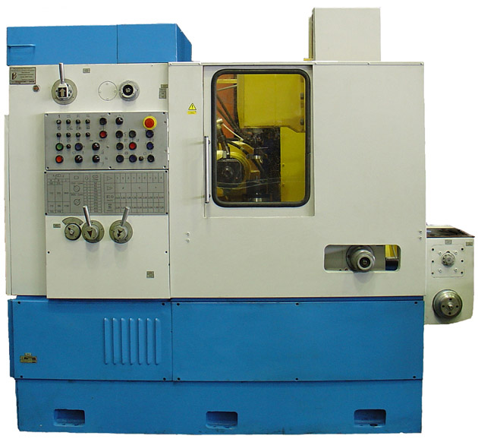
вввмммммвииии  53В30P GEAR HOBBING SEMIAUTOMATIC MACHINES | The semiautomatic machines with upright axis of workpiece for treatment of spur and helical gears, sprockets, worm wheels with hobs by method of form-generating.  CE
вввмммммвииии  53В30P GEAR HOBBING SEMIAUTOMATIC MACHINES | Delivery terms: FCA Vitebsk (Incoterms 2010)  Payment terms: L/C, 100% prepayment  HS code 8461401900  Price: 53B30P – 87600 USD, 53B30P-22 – 104000 USD  Net weight – 5100 kg  210627, Republic of Belarus, Vitebsk, Dimitrova str, 36/7  Tel. + 375-212-370926, 370972, 376673  Fax +375-212-363153, 364284  www.vistan.ru e-mail: vistan_ves@yahoo.com
53В30P GEAR HOBBING SEMIAUTOMATIC MACHINE
53В30P-22 STRUCTURAL FEATURES:

- The semiautomatic machine 53В30P has a configuration with upright axis of workpiece and with movable table. The hydraulic cylinder of blanks′ clamping is built into the table′s spindle.
- The semiautomatic machine 53В30P is equipped with the relay control system.
- The semiautomatic machine 53В30P-22 is equipped with the SIEMENS programmable controller and drives.
- Adjustment of rotational speed of hob spindle as well as of values of axial and radial feeds is realized with frequency converters-powered asynchronous or servomotors (depending on version) steplessly.
- High static and dynamic rigidity due to rational shape of column and support carriage guides as well as rigidity increase of main shape-creating units.
- To use full length of hob cutting edge its periodical travel along the axis (shifting) is provided.
- It is possible to install the tangential support on the semiautomatic machines to realize tangential feed along the axis of hob.
- The semiautomatic machine have a centralized lubrication system.

TECHNICAL DATA
 | 53В30P (-22)
Maximal outer diameter of gear to be cut, mm | 320
Maximal module to be treated, mm | 6
Maximal helix angle of teeth to be cut, deg. | ±60
Maximal width of spur gear face to be cut, mm | 220
Diameter of table, mm | 250
Distance between the tool axis and the table axis, mm:  minimal/maximal | 30…250
Maximal diameter of hobs to be installed, mm
- diameter | 160
- length | 160, 220*
Maximal hob travel along the axis (shifting), mm | 75
Range of numbers of hob revolutions, rpm | 50…500
Range of upright feeds, mm/rev.; mm/min. | 0,63…7,3
Range of radial feeds, mm/min. | 1…16
Range of tangential feeds, mm/rev. | 0,26…2,3
Power of two-speed primary motion drive, KW | 3,2/4,2;  7,5* (4,0/4,75)
Number of coordinates to be controlled
Overall dimensions, mm | 2300x1300x1950
Weight of the semiautomatic machine, kg | 5100
* - on special order



