  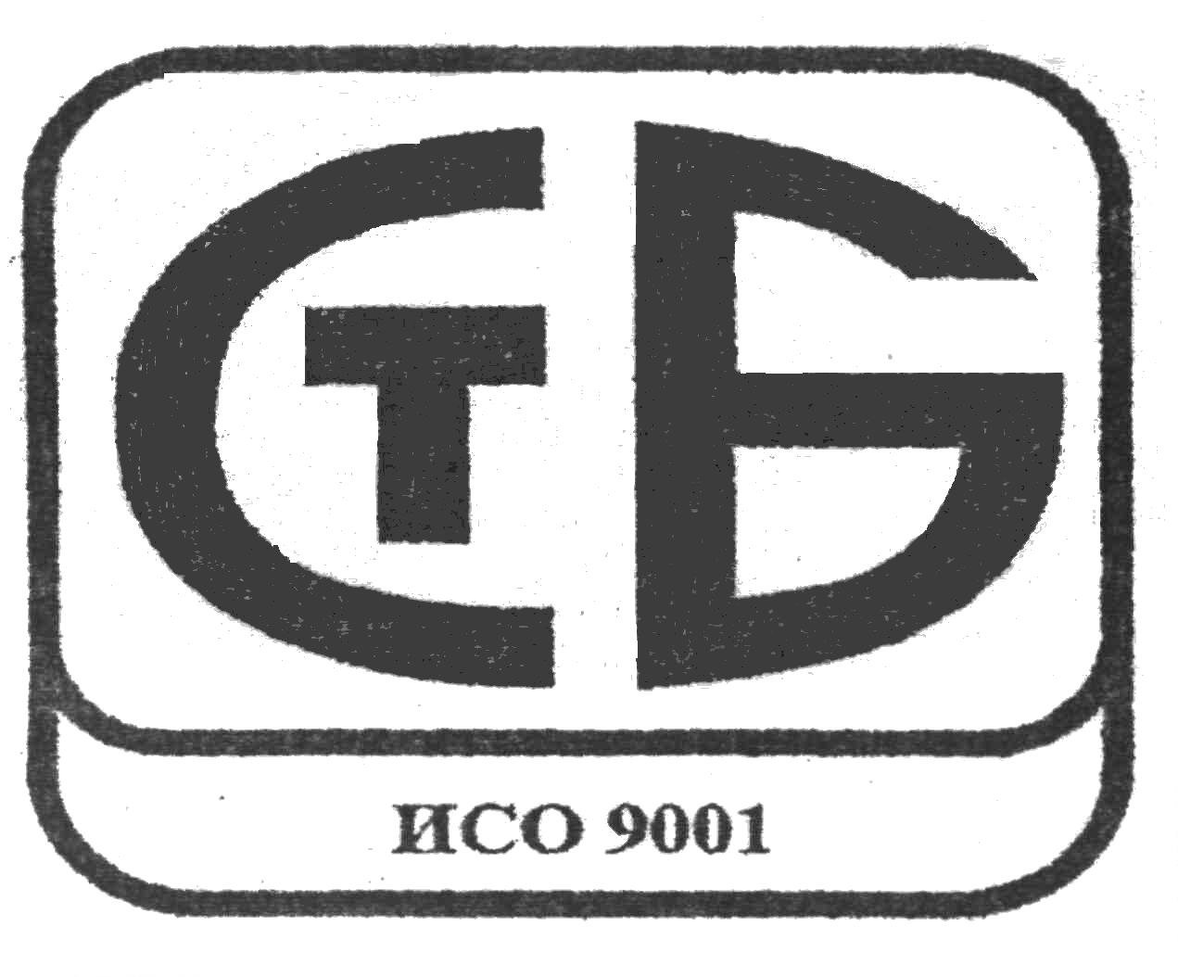  Republic of Belarus  Open Joint Stock Company  "Baranovichi Cotton Production Amalgamation"  (Open JSC "BCPA") |  | Республика Беларусь  Открытое акционерноеобщество  «БАРАНОВИЧСКОЕ ПРОИЗВОДСТВЕННОЕ  ХЛОПЧАТОБУМАЖНОЕ ОБЪЕДИНЕНИЕ»  (ОАО «БПХО»)
c/a 3012122591019 in CBU No 101  Open JSC “BPS-Sberbank” MFO 153001369  7, Fabrichnaya St., 225410 Baranovichi    8(0163) 476371, 476712, fax: 475561  е-mail: reklama@blakit.by, export@blakit.by  Website: www blakit.by  UNP 200166488 OКPO 00311645 |  | р/с 3012122591019 в ЦБУ № 101  ОАО “БПС-Сбербанк” МФО 153001369  ул.Фабричная, 7, 225410 г.Барановичи  8(0163) 476371, 476712, факс: 475561  е-mail: reklama@blakit.by, export@blakit.by  интернет-сайт: www.blakit.by  УНП 200166488 ОКПО 00311645

_________________________№______________

На №___________________ ад ____________

For manager of the company

Business Offer

The Open Joint Stock Company “Baranovichi Cotton Production Amalgamation” is the largest manufacturer of cotton fabrics in Europe and CIS countries. Our amalgamation consists of spinning, weaving, finishing and sewing mills with contemporary equipment and technologies.

Open JSC “BCPA” offers the following goods for sale in the markets of Europe and CIS countries:
1) 100% cotton and mixed yarns. We produce open end and ring-spun yarns for further use by weaving and knitting factories. This product is of high quality which corresponds to physical and mechanical parameters of sort 1, class “А” in accordance with State and European standards as it is produced out of cotton fiber of sort 1, type 5, good and middle classes.

Our mixed yarns contain natural and synthetic fibers in different ratio. Thereby it is possible to combine the properties of different impurities to produce the yarn of the required quality.

Types of produced yarns and their description
Yarn count,  Nm | Yarn count,  tex | HS Code | Technical Normative Legal Act,  its validity
Grey carded yarn out of cotton fiber of type 4-5,
open end, for knitting and weaving
18.5х1 | 54/1 | 5205140000 | ТU BY 00311645.116-2000, TO BY  200166488.885-2009, till 01.09.2014
20.0х1 | 50/1 | 5205130000 | ТU BY 00311645.116-2000, TO BY  200166488.885-2009, till 01.09.2014
25.0х1 | 40х1 | 5205120000 | ТU BY 00311645.116-2000, TO BY  200166488.885-2009, till 01.09.2014
29.0х1 | 34.5/1 | 5205120000 | ТU BY 00311645.116-2000, TO BY  200166488.887-2009, till 01.09.2014
50.0х1 | 20/1 | 5205120000 | ТU BY 00311645.116-2000, TO BY  200166488.885-2009, till 01.09.2014
25.0х2 Yantra | 40.0/2 Yantra | 5205320000 | ТU BY 00311645.116-2000, TO BY  200166488.885-2009, till 01.09.2014
Grey carded yarn out of cotton fiber of type 4-5,
ring-spun, for knitting and weaving
25.0х2 | 40/2 | 5205320000 | ТU BY 00311645.116-2000, TO BY  200166488.724-2007, till 14.05.2012
Cotton/polyester yarn out of cotton fiber of type 4-5,
open-end, for weaving with 67% of grey PE
29.0х1 | 34,5/1 | 5509530000 | ТU BY 00311645.116-2000, TO BY  200166488.977-2010, till 30.09.2015
50.0х1 | 20/1 | - | ТU BY 00311645.116-2000, TO BY  200166488.1019-2011, till 21.02.2016
Cotton/polyester yarn out of cotton fiber of type 4-5,
open-end, for knitting with 67% of black PE
20.1х1 | 50/1 | 5509530000 | ТU BY 00311645.116-2000, TO BY  200166488.825-2008, till 29.05.2013
Cotton/polyester yarn out of cotton fiber of type 4-5,
open-end, for knitting with 20% of black (white) PE
20.0х1 | 50/1 | 5206120000 | ТU BY 00311645.116-2000, TO BY  200166488.1073-2011, till15.12.2016
Cotton/polyester yarn out of cotton fiber of type 4-5,
open-end, for knitting with 8% of grey PE and 12% of black PE
20.1х1 | 50/1 | 5206130000 | ТU BY 00311645.116-2000, TO BY  200166488.969-2010, till 17.08.2015
Cotton/polyester yarn out of cotton fiber of type 4-5,
open-end, for knitting with 10% of black PE
20.0х1 | 50/1 | 5205130000 | ТU BY 00311645.116-2000, TO BY  200166488.1073-2011, till 15.12.2016
Cotton/polyester yarn out of cotton fiber of type 4-5,
open-end, for knitting with 10% of black PE, 6%, 8%,10%, 12%/ 14%
25.0х1 | 40/1 | 5206120000 | ТU BY 00311645.116-2000, TO BY  200166488.885-2009, till 01.09.2014
Cotton/polyester yarn out of cotton fiber of type 4-5,
open-end, for knitting and weaving from machine AUTOCORO
25.0х1 | 40/1 | 5205120000 | ТU BY 00311645.116-2000, TO BY  200166488.885-2009, till 01.09.2014

The selling prices are established on FCA-terms and in case of tare refund.

The selling prices are established for yarn of sort 1, class “B”. For yarn of class “А” we apply the prices with allowance of 1%, for yarn of sort 2 and 3 - with discounts of 3% and 5% respectively.

The yarn is sold on terms of 100% prepayment and payment within 15 and 30 calendar days.

2) 100% cotton fabrics. We manufacture grey, bleached, uni-dyed and printed fabrics of different weight from 84 to 244 g/m² and width from 90 to 220 cm. The fabric production is presented by calico, sheeting, linen, dress and technical groups of fabrics for:

Bed linen;

Table linen;

Costumes and dresses;

Fabric for overalls;

Medical fabrics (bandage, gauze).

Some kinds of the manufactured uni-dyed fabrics and their characteristics:
No | Description of fabric | Article | Width, cm | Weight, g/m² | HS Code
1 | Sheeting for dress | 134 | 100,0±1,5 | 142-7 | 5208329600
2 | Flannel | 1672 | 90±1,5 | 200-10 | 5208390000
3 | Sheeting for bed linen | 484 | 150±2,0 | 138-7 | 5208329600
4 | Calico for bed linen | 920 | 150,0±2,0 | 100-5 | 5208310000
5 | Calico for bed linen | 836 | 100,0-1,5 | 101-5 | 5208321600

Some kinds of the manufactured printed fabrics and their characteristics:
No | Description of fabric | Article | Width, cm | Weight, g/m² | HS Code
1 | Sheeting for linen | 131 | 145±2,0 | 142-7 | 5208520000
2 | Sheeting for linen | 484 | 150±2,0 | 138-7 | 5208520000
3 | Waffle | 351 | 95±2,0 | 205-10 | 5209590000
4 | Fabric for linen  sateen | 943 | 220,0-2,5 | 118-6 | 5208599000
5 | Fabric for linen | 857 | 220±2,5 | 134-7 | 5208520000
6 | Fabric for bed linen | 1030 | 220±2,5 | 120-6 | 5208221900
7 | Fabric for bed linen | 1037 | 220±2,5 | 120-6 | 5208520000
8 | Fabric for bed linen | 1071 | 155±2,5 | 120-6 | 5208520000
9 | Fabric for bed linen | 1077 | 220-2,5 | 118-6 | 5208520000

Some kinds of the manufactured grey fabrics and their characteristics:
No | Description of fabric | Article | Width, cm | Weight, g/m² | HS Code
1 | Sheeting for linen | 484 | 168,7±2,0 | 145-7 | 5208129900
2 | Dress fabric | 570 | 164,4-2,5 | 244-12 | 5209120000
3 | Calico for linen | 823 | 115,8-1,5 | 104-5 | 5208121600
4 | Sheeting for linen | 4744 | 145,0-2,0 | 146-7 | 5208129600

Some kinds of the manufactured bleached fabrics and their characteristics:
No | Description of fabric | Article | Width, cm | Weight, g/m² | HS Code
1 | Calico for linen | 823 | 100,0-1,5 | 103-5 | 5208221600
2 | Calico for linen | 836 | 100,0-1,5 | 101-5 | 5208221600
3 | Sheeting for linen | 258 | 145,0-2,0 | 142-7 | 5208229600
4 | Sheeting for linen | 484 | 150-2,0 | 140-7 | 5208229600
5 | Cotton fabric for linen | 1030 | 220-2,5 | 120-6 | 5208221900
6 | Cotton fabric for linen | 857 | 220-2,5 | 134-7 | 5208229900
7 | Medical gauze | 1089 | 105±2,0 | 43-2 | 5208211000
8 | Two-layer gauze | 1059 | 80±2,0 | 102-2 | 5208290000
9 | Waffle | 351 | 95,0-2,0 | 205-10 | 5209290000
10 | Cotton fabric for table linen | 570 | 150±3,0 | 230-12 | 5209220000

3) Ready-made goods:
- Bed linen sets (single and double bed sets, "Euro" and "Duet" bed sets);
- Souvenirs (kitchen and table linen sets);
- Medical dress;
- Sauna sets.

More information is on our web-site www.blakit.by

Delivery terms: FCA-Baranovichi (Belarus).
Sales terms: negotiations, tenders.
Minimum order: from 10,000 USD.
Discounts: on a monthly order of 30,000 USD a discount of 3% may be given.

Whether you have any questions, please do not hesitate to contact us. We are looking forward to your requests and hope for our mutually beneficial cooperation.

Our address:
7, Fabrichnaya Str., Baranovichi, Brest region, Belarus.

Tel.: +375-163-476778 – Marketing Department

+375-163-476010 – Export Department

e-mail: otdel.ves@yandex.by

Best regards,

Sergey Kuksa
Sales Director
OJSC “BCPA”

Eng. trans.: Natalia Volkova-Filippova

