Open Joint-Stock Company «GOMEL FOUNDRY PLANT «TSENTROLIT» is one of the largest enterprises in Belarus. It was founded in 1963.
It specializes in producing castings from grey cast iron (GG20, GG 25 GOST 1412-85) and ductile cast iron (GGG 50 GOST 7293-85 ).
The foundry provides with castings practically all the industrial enterprises: in machine-tool construction and mechanical engineering industry, in machine building and metro construction. The foundry plant has also mastered the production of art castings that are used for urban design.
Castings for machine-tool construction
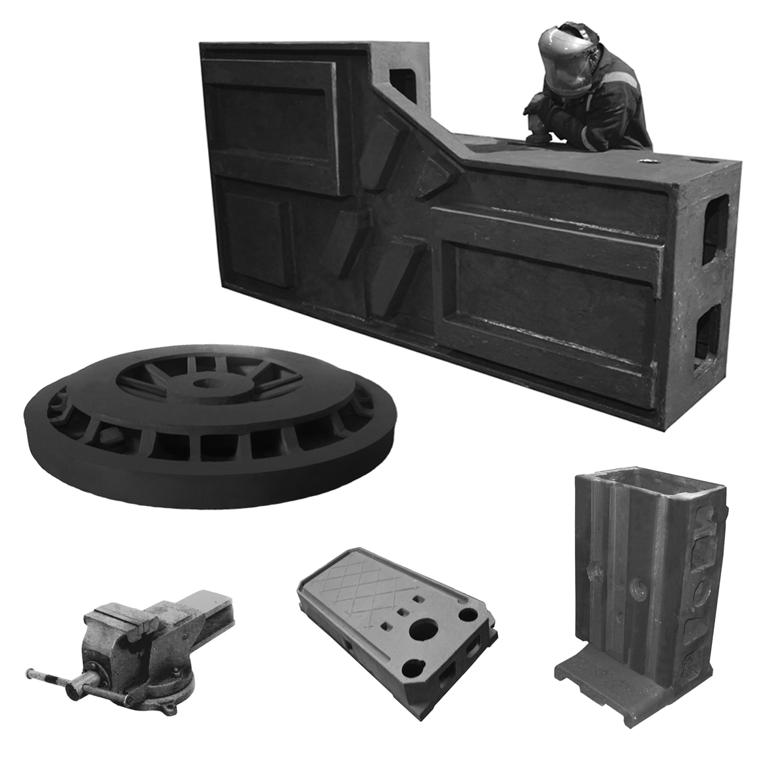
(bodies, beds, cross-bars, faceplates, carriages, boards, covers and etc.)

Material: GG20-GG25 (GOST 1412-85), weight: up to 14000 kg;

GGG50 (GOST 7293-85),
weight: up to 10000 kg.
Max. flask dimensions:
7500x1900x1200/600,
4000x1500x1000/450,
4000x3000x600/470,
2000x1400x600/350/500,
1600x1200x500/350,
700x960x300,
760x810x270/300,
750x800x250/250
Customs commodity code 8466 93,
8205 70

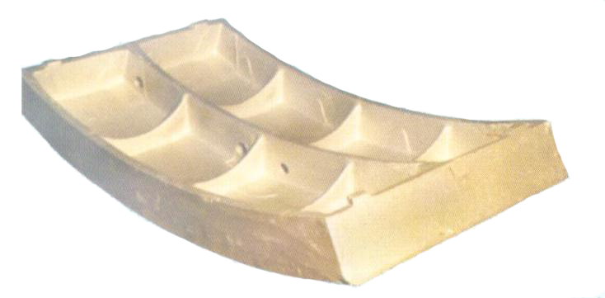
Тubing rings

Cast iron tubing rings are assembled mounting vaults for underground structures (tunnels, mines, underground). A tubing ring consists of separate segments that are connected into a ring. Several connected rings make tubing lining.
Маterial: GG20-GG25 (GOST 1412-85)
Customs commodity code 7325 10

Contacts:

ОJSC «GFP «TSENTROLIT»
246647, the Republic of Belarus, Gomel, Barykin street, 240
www.glz-centrolit.by, www.centrolit.com

Fax: + 375 232 46 05 45



Open Joint-Stock Company
«GOMEL FOUNDRY PLANT «TSENTROLIT»

Castings for mechanical engineering
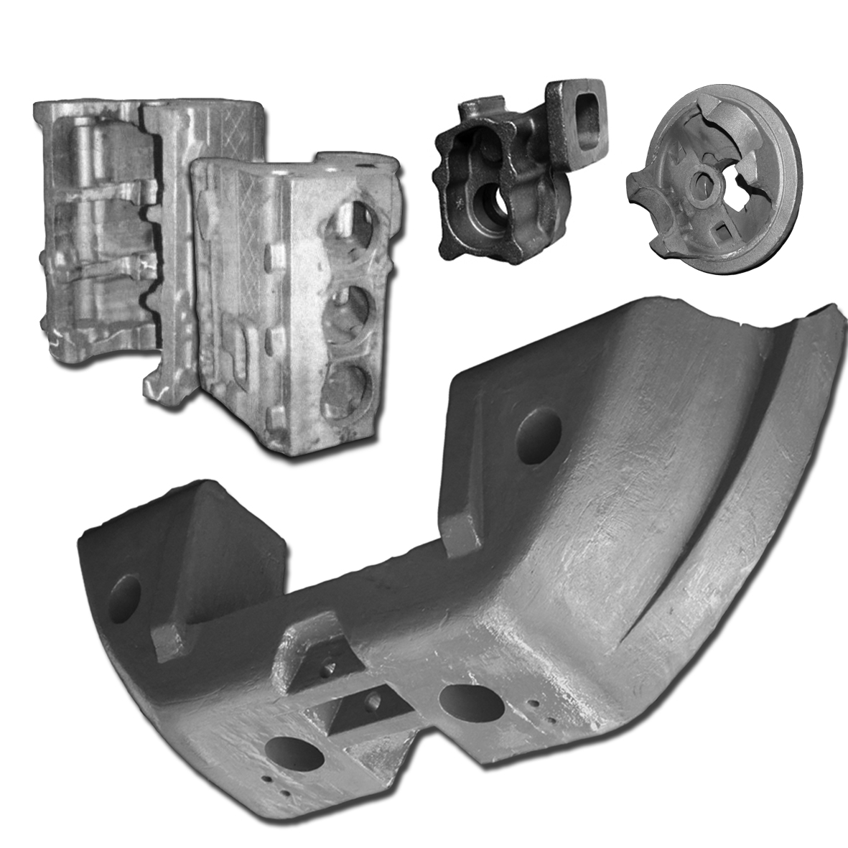
(bodies, hubs, crank cases, carriers, gear boxes, brake drums ,counterweights)

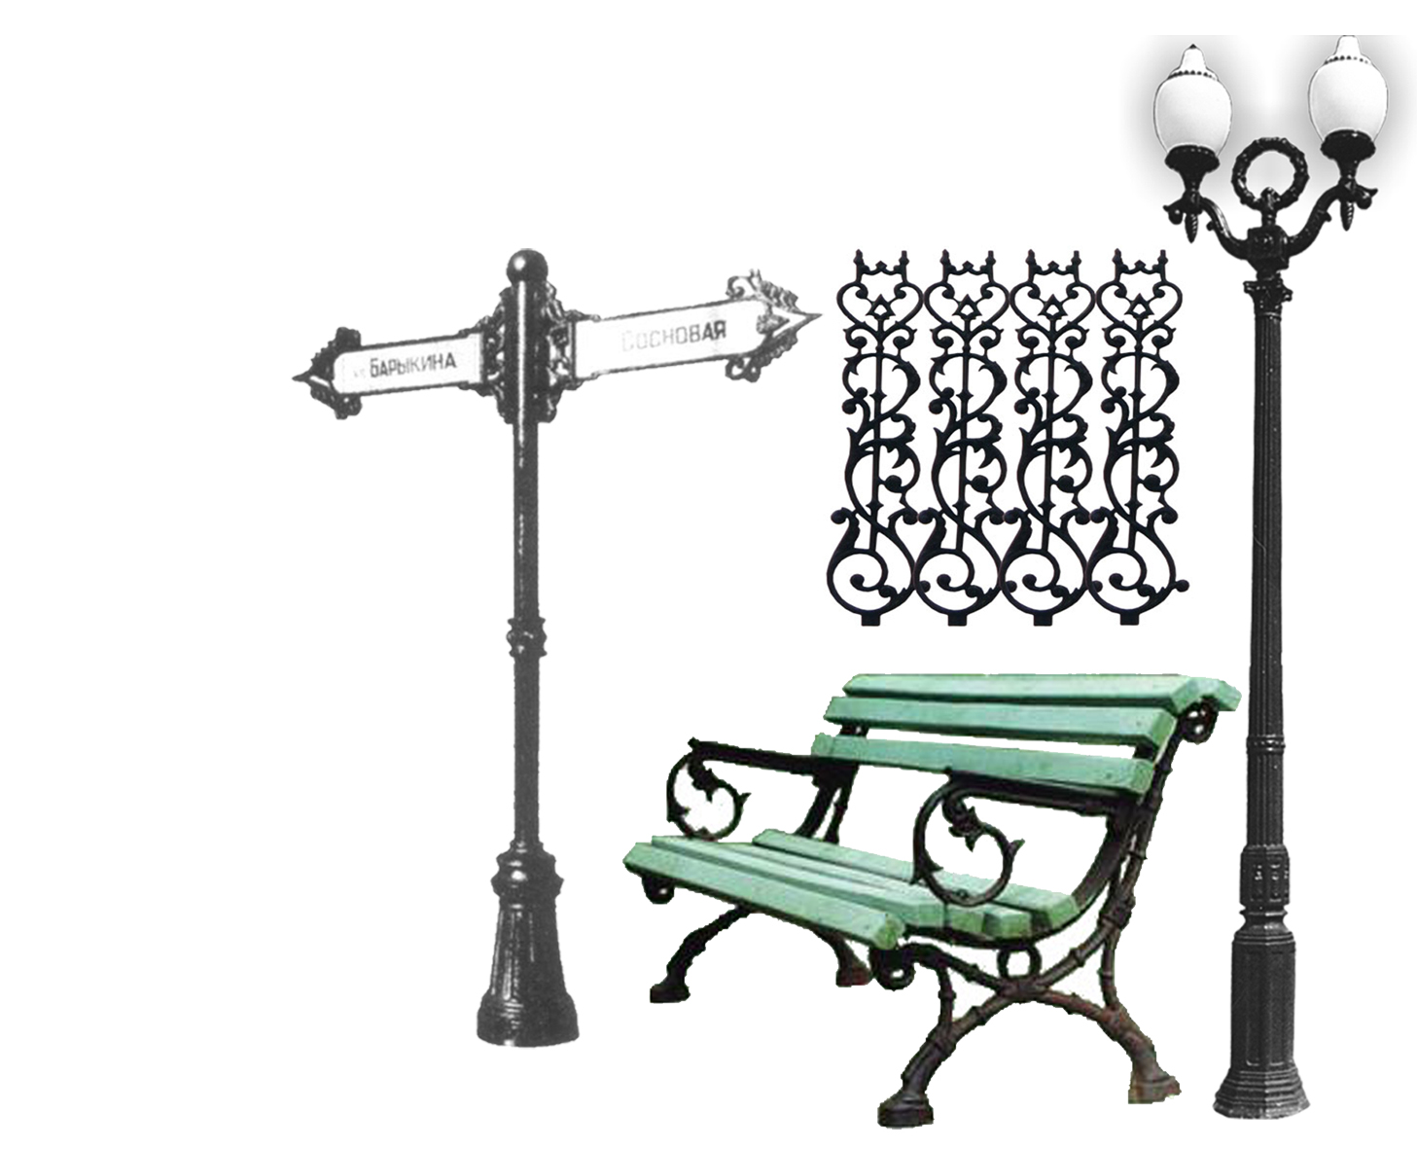
Маterial: GG15-GG25 (GOST 1412-85), weight: from 2 up to 14000 kg;

GGG50 (GOST 7293-85),
Weight: from 2 up to 10000 kg.
Customs commodity code 8431 91,
8431 49, 8483 90, 8708 94

Continuous castings
(rod, strip)
Continuous castings made from grey cast iron GG20- GG25 (GOST 1412-85) have the following cross-sectional dimensions: Ø30-Ø230 mm and the length up to 2,500mm; from ductile cast iron GGG50 (GOST 7293-85): Ø50-Ø170 mm and the length up to 1500mm, or profiles of any configuration that fit in Ø 230mm. The quality grade GTB17 to DIN 1685. The weight tolerance is 10%. The surface roughness is Rz160.
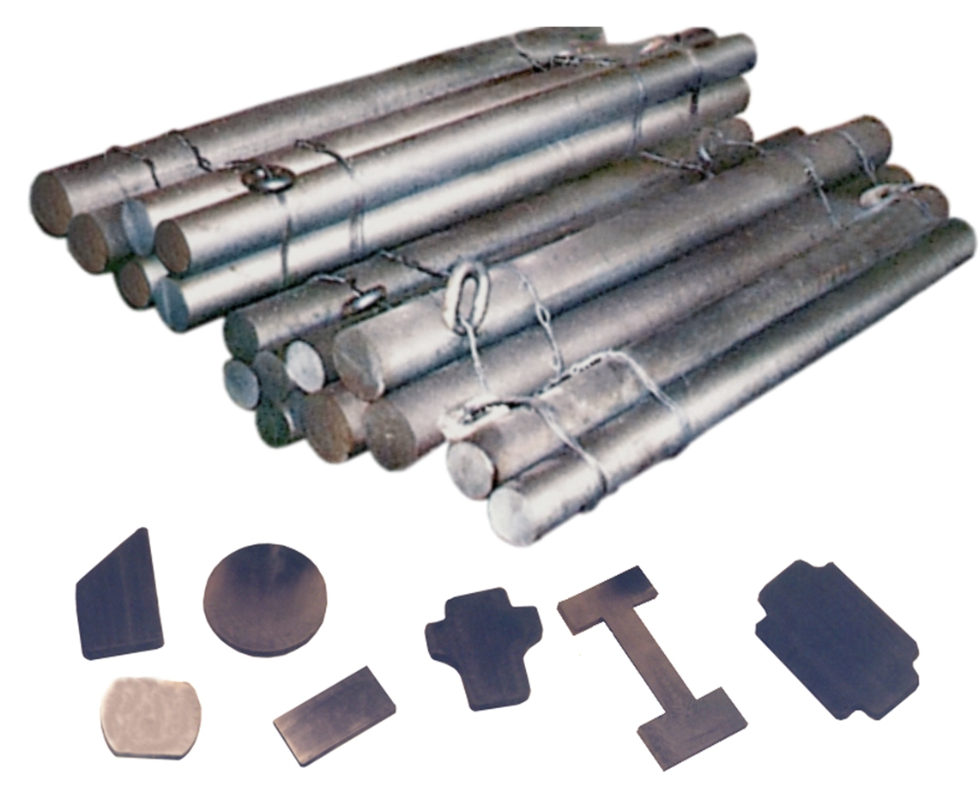

These billets are distinguished by fine-grained, thick, uniform basic structure, free of cavities, with little difference in the firmness and uniformity of distribution of the graphite structures, identical in shape and size, that makes it possible to process metal cutting perfectly.
Customs commodity code 7325 10

Lutskovich Vasily Grigorievich – Deputy Director of Marketing and Economic Affairs
e-mail: info@glz-centrolit.by
info@centrolit.com

Tel.:+375 232 46 43 81


Products for urban design

Our plant produces cast iron street lamps and posts, that will complement landscape design and decorate streets of a city; benches and urns, cast iron fence gratings of different types and design, street bowers, sculptural figures for a park and so on.
Customs commodity code 9401 90,
8306 29

Road fittings
(floating manholes, light-,medium- and heavy weight manholes, garden manholes ; rain gullies and rainwater gratings of different types and size)
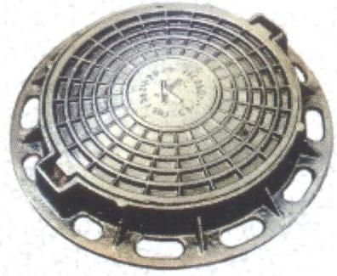
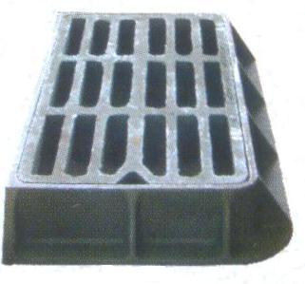

These castings are made according to GOST3634-99 and GOST 8591-76. Customs commodity code 7325 10
Our products are certified according to the Quality Management System of the International Standard ISO 9001-2009, EN DIN 124.
Products are delivered: FCA –Gomel.
Sales terms are agreed by means of direct negotiations.
The plant has been cooperating with companies in Russia, Ukraine, Finland, Kazakhstan for many years. We would like to cooperate with countries of CIS and abroad.

Zenenko Alla Gennadievna – Head of the Marketing Department
e-mail: info@glz-centrolit.by
info@centrolit.com

Tel.:+375 232 46 43 79, 46 05 31

