25 | August | 0 | 03-01-004/
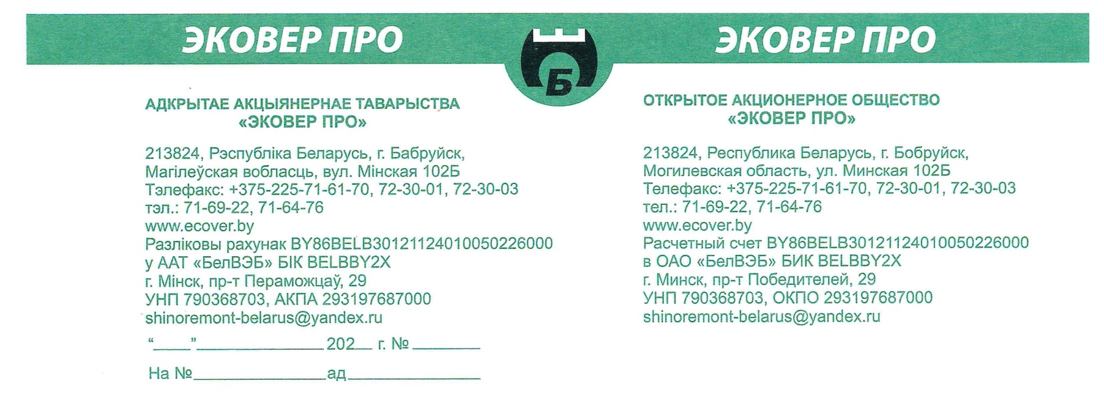

Commercial proposal
Ecover PRO, OJSC

Ecover PRO, OJSC is one of Belarusian enterprises for recycling tires for trucks, buses and trolleybuses. In 2014, the enterprise introduced equipment for manufacturing injury-free rubber flooring. Design organizations, construction companies, agricultural organizations, farms, retail and wholesale trade networks are invited for cooperation.
Products are manufactured under FEACN code:
4016910000 – “Other floorings and mats of vulcanized rubber”.
Ecover-Pol rubber tile has passed all the required tests in accordance with applicable standards of the European Union (hereinafter - EU) and has received the following certificates of conformity:
- EN 13501-1 + A1 (Efl class (fire resistance) in accordance with EU standards);
- EN 14041: 2004 (DL technical class (slip resistance) in accordance with EU standards);
- EN 14904: 2006 (sports field flooring, interior flooring for various sports in accordance with EU standards);
- EN 1177: 2008 (critical falling height in accordance with EU standards).
These certificates provide the possibility of selling the products on the territory of EU countries with no necessity of issuance of any additional documentation.
Rubber tile size: 500x500mm (16 - 50mm thick).
Rubber curb size: 500x240mm (50mm thick).
“Ecover-Pol” rubber tile is manufactured in 8 basic colors: green, red, blue, yellow, orange, gray, white, black.
Rubber tile range of use:
- playgrounds and sports grounds;
- garden paths and recreation zones;
- swimming pool areas;
- garages, car repair shops and washes;
- industrial premises.
In 2020 our company implemented a project for agricultural mats manufacturing. This is a modern type of flooring for livestock premises. Main features of agricultural rubber mats are deformation resistance, long service life, water resistance, environmental safety and corrugated surface. All these qualities positively affect livestock health.
Today, Ecover PRO, OJSC serially manufactures and offers 1900x1200-mm and 1830x1200-mm agricultural mats with thickness from 15 to 20 mm made of high-quality rubber compounds.
More detailed information on Ecover PRO, OJSC products and their images are available on: http://ecover.by/

We hope for continuous and mutually advantageous cooperation.

Ecover PRO, OJSC
102B Minskaya str., Bobruisk city, Mogilev region, Republic of Belarus
Contact numbers:
Reception: +375 (225) 71-61-70
Nikolay Viktorovich Desyatnik, the Head of Marketing and Sales dpt.:
+375 (225) 71-61-29
Ph./fax: +375 (225) 72-30-03,
e-mail: info@ecover.by

Appendices:

Price list

Advertising brochure

