Humanitarian project“Education without borders”
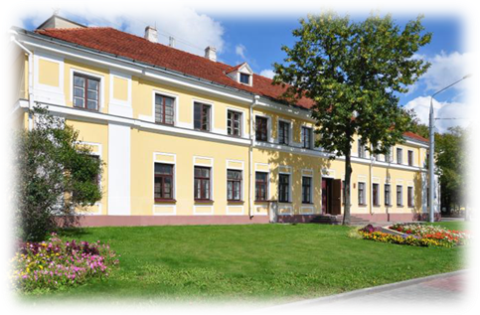
1. Project title: “Education without borders”.
2. Project dates: 12 months.
3. Name of the organization-applicant: State educational institution “Grodno Children's Art School named after Anthony Tizengayz”.
4. Project goal:
1) сreation of a modern educational center on the territory of the State institution of education "Grodno Children's Art School named after Anthony Tizengauz";
2) creating conditions for the formation of accessibility for Belarusians and foreign "applicants" of educational and information resources in the field of culture and ensuring the use of the possibilities of educational institutions;
3) improving the educational system in the field of culture through the strengthening and strengthening of humanitarian ties, the development of closer contacts in a single cultural space with the cities of the European Union;
4) preservation at the local level of cultural, musical, historical and educational traditions;
5) involvement of the population in active participation in educational life in the field of culture;
6) organization and conduct of training seminars, forums, webinars, distance learning courses, trainings, round tables, workshops, open lessons through online communication;
7) development of the moral value of the personality of the student, its artistic and creative potential.
5. Project objectives:
1) expanding access to quality services in the field of education, training and continuing education through the development of infrastructure;
2) the acquisition of technical equipment for educational events (tablets, computers, interactive whiteboards, televisions, screens, video projectors, cameras, etc.);
3) attraction of employees of educational institutions of the city, region to participate in the educational program;
4) organization of the educational process through the technical capabilities of the art school;
5) organization of leisure activities of project participants, concerts;
6) acquisition of an indoor stage venue for the organization of leisure activities of project participants;
7) the acquisition of stage and lighting equipment, musical concert equipment;
8) cooperation with the media to popularize the project.
6. Beneficiaries: the population of Grodno aged 6 to 55 years.
7. Brief description of project activities:
- organization of preparatory activities for the preparation of the project;
- preparation of a list of necessary technical equipment;
- preparation of design estimates;
- negotiating with potential employees – “teachers”;
- negotiating and organizing the procurement of technical equipment necessary for the implementation of the project;
- drawing up a plan of educational activities and activities;
- Negotiating with creative teams and performers to attract them to participate in creative events;
- production of albums, booklets, other promotional materials;
- record audio and video materials for the project;
- оrganization of cooperation with the media for the promotion and advertising of the project.
8. Amountrequested in USD:150000
Sourceoffinancing | volume of financing in USD
Donorfunds | 145 000
Co-financing (own contribution) | 5 000
9. Project location (region, town):Grodno region, Grodno.
10. Contact person:
KavalchukVolha, Deputy Director, +375297865177, +375152625376, tizengayz@mail.ru

