**FOOD SECURITY AGENDA SHOULD BE PART OF THE SANCTIONS DISCUSSION**

Removing 20% of Potash from the market can create very adverse impacts in the whole food chain.

Potash is a key nutrient for all plants, all around the globe, and has no substitutes.

Production is very concentrated, with Canada, Russia and Belarus representing about 70% of global production.

Belaruskali is the largest Potash producer in the world, accounts for 20% of world Potash exports, and cannot be replaced on short notice (new mines take long years and big investments).

Removing Belarus from the picture, total or partially, will further increase concentration towards Canada, but especially Russia.

Market is very balanced/tight already, and sanctions discussions have already impacted potash prices drastically. Adjusted for the gas effect (N) and China restrictions on exports (P), the Potash prices have increase drastically more (almost 3 fold) compared to other nutrients.

Grain stocks are continuing to dangerously decrease.

FAO Food Price Index is at historical high, and continuing to raise.

More people are starving, while food is becoming more scarce and expensive.

“Food production is needed rather urgently, and the world needs ALL fertilizers that can be supplied, including from Belarus”.

**WORLD POTASH PRODUCTION AND TRADE 2019 - IFA**

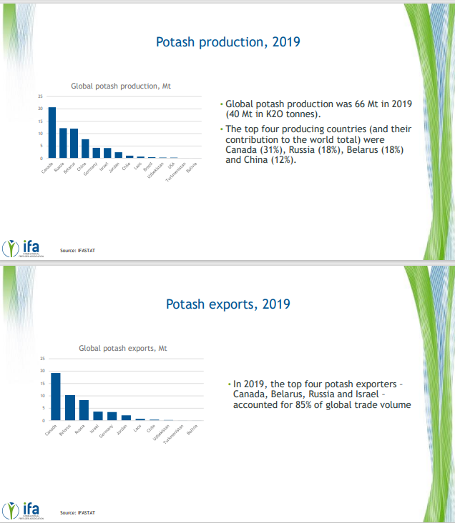

Potash trade is even more concentrated than the production.

On a company basis, Belaruskali is the largest producer.  
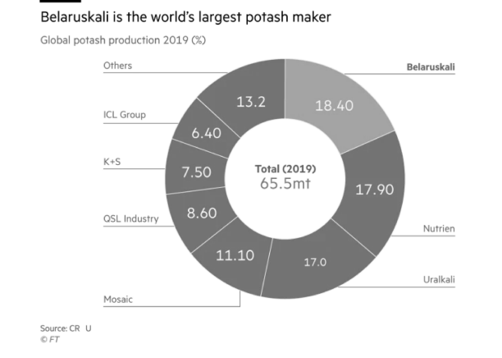

**NEW PROJECTS TAKE A LONG TIME AND SIGNIFICAT CAPEX TO CONCLUDE**

BHP JANSEN PROJECT, STILL 6 to 8 YEARS ON TOP OF THE SEVERAL YEARS INVESTED ALREADY

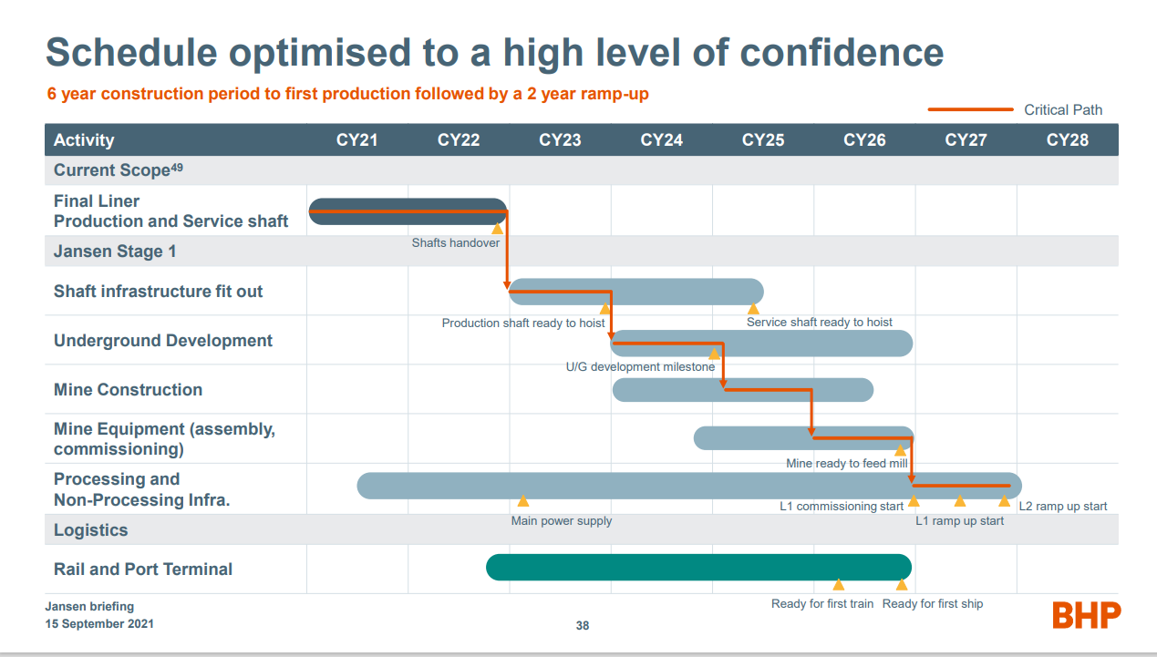

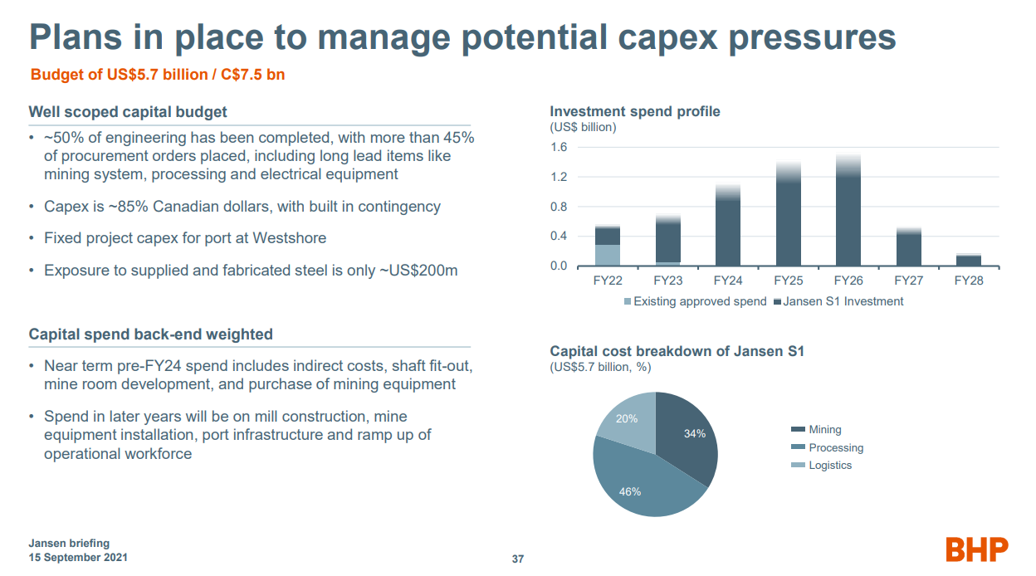

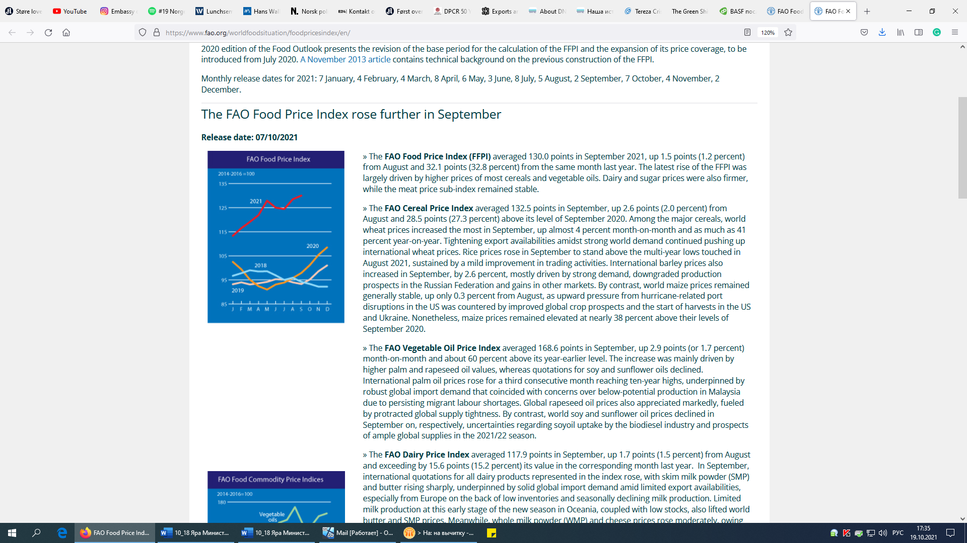

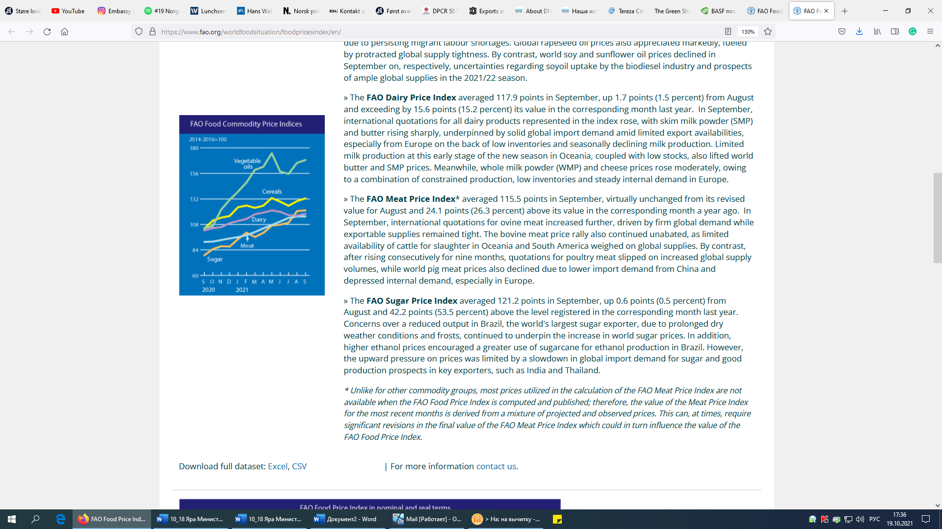

**POTASH PRICES INCREASING SHARPLY**

Potash increasing relatively much higher vs other nutrients

**US GOLF BARGE MARKET DEVELOPMENT 2021 – Prices development of the 3 key nutrients**

|  |  |  |  |  |  |  |  |  |  |
| --- | --- | --- | --- | --- | --- | --- | --- | --- | --- |
| **USD/st** | Jan | Feb | Mar | Apr | May | Jun | Jul | Aug | **Jan/Aug** |
| **Urea(N)** | 308 | 342 | 379 | 374 | 374 | 431 | 430 | 410 | **33%** |
| **DAP (P)** | 429 | 529 | 535 | 540 | 574 | 605 | 610 | 608 | **42%** |
| **MOP(K)** | 257 | 300 | 320 | 314 | 336 | 422 | 526 | 548 | **113%** |

And some key markets in the world with increases over 170%

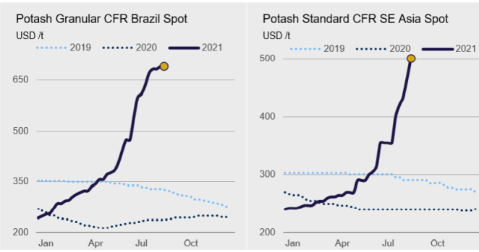

Market intel and publications

To be noted that Potash is a “perfect” global commodity, and that price increases affect all markets in the world, independent of having or not local production.

**SUPPORTING DOCUMENTS**

**IFA – International Fertilizer Association**

“Farmers’ access to inputs such as fertilizers is vital for food security. There is a strong link between people’s nutrition and the amounts and types of minerals available in soil and plants. This is because plants are the primary source of nutrients for people and animals.

Potash (potassium) and plants. Potassium has major functions in enzyme activation, transpiration and the transport of assimilates (the products of photosynthesis). It helps plants retain water during droughts, provides strength to plant cell walls and decreases susceptibility to diseases and insects.

Potash (potassium) and people. Potassium is vital for the proper functioning of cells, and muscles and nerves depend on it. Since potassium cannot be stored in the body, it must be continually replaced by foods rich in potassium.

Potash-based fertilizers are produced from mined ores. Mines can take months or longer to make changes in production, there is not always a quick way to bridge gaps in supply. It also takes several years to construct newbuild processing plants to upgrade the mined ores into finished fertilizer products.”

To see the complete IFA Global Food Security fact sheet, access the link below: [https://www.fertilizer.org/public/resources/publication_detail.aspx?SEQN=6159&PUBKEY=D99ED715-91F4-4899-8E7D-4B5F00391327](https://eur03.safelinks.protection.outlook.com/?url=https%3A%2F%2Fwww.fertilizer.org%2Fpublic%2Fresources%2Fpublication_detail.aspx%3FSEQN%3D6159%26PUBKEY%3DD99ED715-91F4-4899-8E7D-4B5F00391327&data=04%7C01%7C%7C518f572c675640b3c23f08d930297863%7Cef8a53ea1a1c4189b792c832dcaea568%7C0%7C0%7C637593776976752663%7CUnknown%7CTWFpbGZsb3d8eyJWIjoiMC4wLjAwMDAiLCJQIjoiV2luMzIiLCJBTiI6Ik1haWwiLCJXVCI6Mn0%3D%7C1000&sdata=2P4c1ZToOVboSoYjvueJSevZuXW9zVRakVhsys7M31o%3D&reserved=0)

**TFI – The Fertilizer Institute**

“All mineral fertilizer products have the potential to suffer supply disruptions. At the most local scale, markets with relatively few players such as potash can suffer disruptions as a result of a single mine or plant going out of operation or no longer having access to the market. In 2019, the top four potash exporters – Canada, Belarus, Russia and Israel – accounted for 85% of global trade volume (IFA: IFASTAT). Producer-level disruptions can occur as a result of technical issues, natural disasters, geopolitical tensions and other unforeseen factors.

Governments across the globe designated fertilizer as an essential good in the early part of the Covid-19 pandemic, an indicator of its vital role in the agriculture value chain, and they should continue to do so.

A [note on nutrition security](http://www.fao.org/documents/card/en/c/ca9692en/), some 3 billion people cannot afford a basic healthy diet that contains all the essential nutrients for a healthy life.

Farmers’ access to inputs such as fertilizers is vital for food security. There is a strong link between people’s nutrition and the amounts and types of minerals available in soil and plants. This is because plants are the primary source of nutrients for people and animals.” To see the complete TFI “Global Food Security – a critical issue” report, access the link: <https://www.tfi.org/content/global-food-security-critical-issue>