Humanitarian project "Green House"
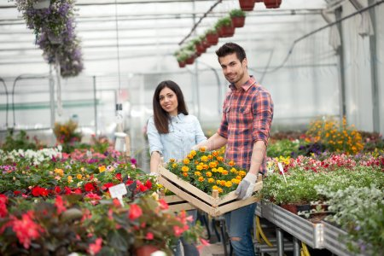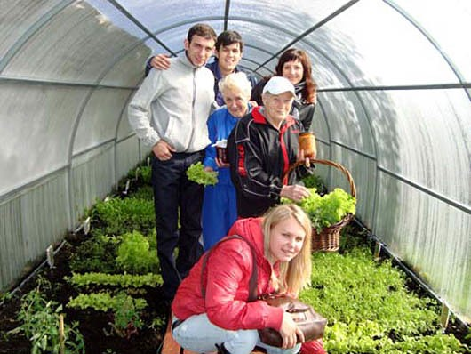
1. Project Name: Green House
2. Project implementation period: 1 year
3. The applicant organization proposing the project: State social service institution "Psychoneurological Residential Center for the Elderly and Disabled in Novogrudok"
4. The aim of the project: the formation and development of the ecological and labor culture of the residents of the residential center.
5. Objectives suggested for the implementation in the framework of the project:
  - training of labor skills of the residents of the residential center for further possible professional self-realization;
  - promotion of environmental and labor education, development of independence of the residents of the residential center;
  - providing the residential center with flowers, ornamental plants and environmentally friendly fortified greenery.
6. Target group: 50 people aged from 18 to 31 years.
7. Brief description of the project activities:
  - Purchasing and installation of the necessary equipment (greenhouse, heating system, shelving);
  - Purchasing of garden tools, building materials, planting materials;
  - conducting classes, workshops on growing seedlings.
8. Total amount of finance (in US dollars) - 40 400
Source of financing: | Volume of financing in US dollars
Donor funds | 40 000
Co-financing | 400
9. The location of the project: The Republic of Belarus, Grodno region, Novogrudok district, Bolshiye Karnyshi village.
10. Contact person:
Natalya Makus, Director of the State Institution of Social Services "Psychoneurological Residential Center for the Elderly and Disabled in Novogrudok" tel./fax 8 01597 4-23-65 / e-mail: novogr.di@mintrud.by

