Equipping State Institution "Center for Social Services of the Population of Grodno Lenin District" with innovative technologies for improving accessibility and quality of social services for people with visual and hearing impairments
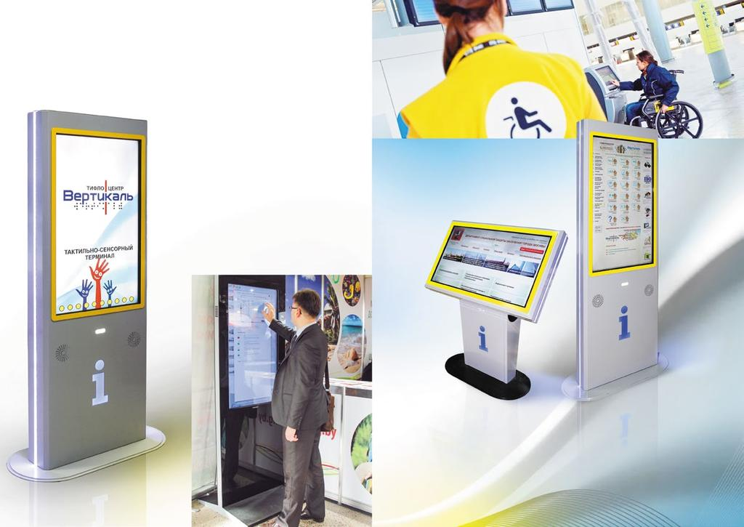

1. Project name:
Equipping State Institution "Center for Social Services ofthe Population of Grodno Lenin District" with innovative technologies for improving accessibility and quality of social services for people with visual and hearing impairments
2. Project implementation period: 1 year from the beginning of the project implementation
3. The applicant organization: State Institution "Center for Social Services ofthe population of Grodno Lenin District"
4. Project aims:
- Assistance in the successful socialization of the target group through innovative
tools and integration into society of citizens with disabilities.
- Strengthening the facilities and resources of the center to improve accessibility and quality of social services and assistance for people with visual and hearing impairments.
5. Objectives of the project:
1. Equipping the center's infrastructure with technological accessibility equipment for people with visual and hearing impairments.
2. Preparing training programs to train specialists and employees to use technological innovative tools and share the experience with partners.
3. Implementing various activities using technological tools to involve the target group in the created infrastructure.
6. Target group: people with disabilities, visitors to the center with visual and
hearing impairments.
7. Summary of the project activities:
- Purchase and installation of a speech informant for disabled and visually impaired people above the entrance group of the room. It is activated via a device held by a disabled person. The voicemessage is played through the built-in speaker or transmitted via radio to thesubscriber’s device. The sound beacon reproduces information about the organization:name, work schedule, field of activity; directs the disabled person inside the building, plays an orientation sound signal. A speech electronic informant isnecessary for the safe and free movementof visually impaired people without assistance. Using this device, they will be able to navigate more confidently in the building, go to the necessary offices, and live a more fulfilling life.
- The stationary informant is intended for sound and visual adaptation ofrooms and buildings for the visually impaired people and other low-mobility groups.
- Special electroacoustic equipment for people with hearing impairment;
- conducting training seminars for specialists;
- organization of workshops on the use of innovative technologies.
8. Total funding (in US dollars): 100 000
Source of funding | Amount of funding (in US dollars)
Donor funds | 90 000
Co-financing | 10 000
9.Project location: 37 Sotsialisticheskaya str., Grodno, Grodno region, Republic of Belarus
10.Contact person:
V. N. Shabal, Director of State Institution "Center for Social Services of the population of Grodno Lenin District", tel. +375 152 771506

