Humanitarian project «We bring joy to our people»

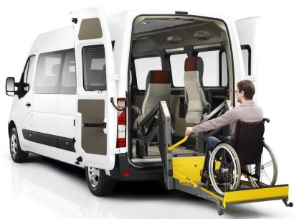

- Project title: We bring joy to our people
2. Project dates: 24 months
3. Name of the organization-applicant: State Institution «Center of Social Services for the Population of Dyatlovо district»
4. Project goal: providing disabled people and elderly citizens with accessible transport services, maintaining and developing their activity, improving their quality of life, providing them with the opportunity to communicate, creating favorable living conditions.
5. Project objectives: Tasks planned for implementation within the project:
creating conditions for meeting the needs of disabled people and elderly citizens in communication, for psychological support, overcoming social stress, sharing life experiences, strengthening physical and mental health, expanding opportunities to participate in public life.
This project is aimed at solving social problems related to the availability of the living environment for representatives of the target group.
6. Beneficiaries:people with limited mobility - disabled people, elderly citizens
7. Brief description of project activities:
purchase of specialized vehicles;carrying out the necessary procedures for the work of social delivery (vehicle registration, vehicle diagnostics, speedometer sealing, car insurance, obtaining a permit to admit a vehicle to participate in road traffic, concluding a contract with a driver);
creation of a computer database for quantitative and qualitative accounting of project implementation and services rendered;
carrying out an information campaign on the work of social transport with the help of the mass media;
provision of free transport services to people with limited mobility.
8. Amountrequested in USD: 50 000
Sourceoffinancing | Amount of financing in USD
Donorfunds | 50 000
Co-financing (own contribution) | 0
8. Project location (region, town): Grodno region/Dyatlovо
9. Contact person: last name, first name, position, phone number, e-mail address:Kostsiuk Galina, head of the Department for senior citizens,
+375 (1563) 61184, E-mail:soc-sluzhba@yandex.ru

