Humanitarian project of the State Institution of Culture "Smorgon District Center of Culture"

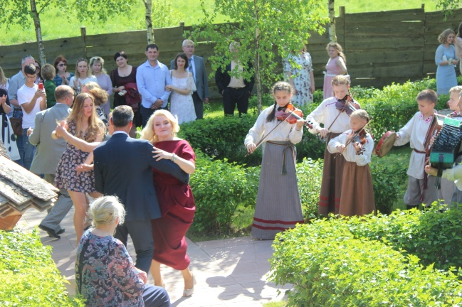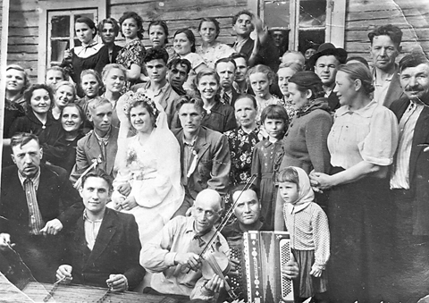

- Project name: Festival of folk instrumental music “You play how you know, I dance like I want”
2. Implementation period: 12 months
3. Applicant: State Institution of Culture "Smorgon District Center of Culture"
4. Project goals: preservation, development and popularization of the Belarusian folk instrumental music
5. Tasks within the project:
5.1 creating conditions for the fixation, preservation and development of the Belarusian folk musical and instrumental tradition;
5.2 attracting the attention of a wide range of people from Belarus and foreign countries to the Belarusian traditional instrumental music;
5.3 popularization of the folk musical and instrumental tradition of the Smorgon region, which is known in the local community as “Smargonskiya najgryshy”;
5.4 Creation of a platform for the cultural exchange of knowledge and skills in the field of folk instrumental music on national and international levels;
5.5 Development of tourism and cultural potential of the countryside.
6. Target group: no limits
7. Brief description of the project activities:
7.1 organization of the festival of folk instrumental music, which will be held once every two years in the estate of Francishak Bogushevich in the village of Kushlyany, Smorgon district:
7.1.1 purchase of a mobile stage complex for the performance of folk musicians;
7.1.2 purchase of 400 folding chairs and 100 tourist rugs for spectators;
7.1.3 purchase of 22 national costumes for carriers of the folk musical and instrumental tradition of the Smorgon region in order to promote the development of this element of intangible cultural heritage;
7.1.4 production of diplomas for the participants of the festival;
7.1.5 rent of a wooden dance floor;
7.1.6 rent of 2 dry-closets;
7.2 creation and promotion of festival advertising in the media and social networks;
7.3 edition of 700 CD-ROM with 30 audio tracks of folk musical and instrumental melodies recorded on the territory of Smorgon district;
7.4 conducting master classes of folk instrumental play by ear, and folk dances;
7.5 production of thematic souvenir gifts to encourage festival participants (magnets, postcards, booklets, keychains, etc.);
7.6 Organization of a scientific and practical conference on the preservation and development of the Belarusian folk musical and instrumental tradition;
7.7 Publication of materials of a scientific and practical conference.
8. Total amount of financing (in US dollars):41 300
Financing source | Amount of financing  (in US dollars)
Donor funds | 41 300
Co-financing | -
8. Place of project implementation (region / district, city): the village of Kushlyany, Smorgon district, Grodno region
9. The contact person:
Elena V. Bobina, Deputy Director of the State Institution of Culture "Smorgon District Center of Culture", +375159224779; +375445353337, rmcznt2011@yandex.ru ; shaturina_elena@mail.ru

