Humanitarian project of a state cultural institution
«Svisloch district center of culture and folk art»

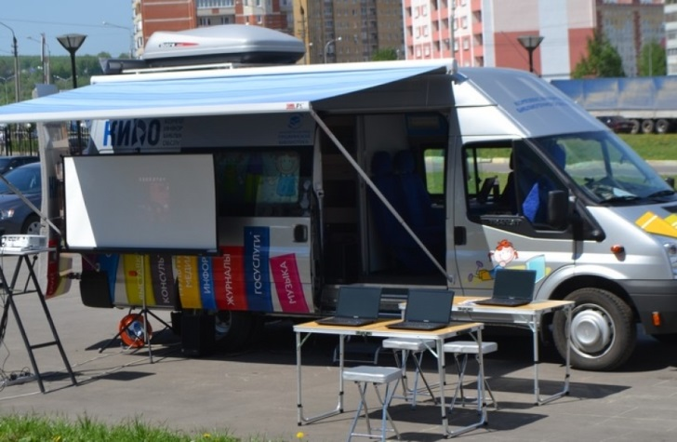

1. Project name:«Living Village»
2. Project duration:12 months
3. Applicant organization proposing the project: state cultural institution «Svisloch district center of culture and folk art»
4. Project objective:ensuring the availability of services in the field of culture and leisure of residents of sparsely populated and remote villages of Svisloch district
5. Tasks planned for implementation within the framework of the project:
– creation of a multipurpose cultural mobile center;
– organization of cultural and leisure services
6. Target group: residents of sparsely populated and remote villages of Svisloch district, people of retirement age, socially vulnerable segments of the population of sparsely populated and remote villages
7. Brief description of the project activities:
– purchase of a specialized multifunctional car club;
– organization and conduct of cultural and leisure activities;
– creation of veteran amateur art groups in sparsely populated and remote settlements
8. Total funding (in US dollars): 50 000
Sourceoffinancing | Amount of funding (in US dollars)
Donorfunds | 45 000
Co-financing | 5 000
9. Project location (region/ district, city): Republic of Belarus, Grodno region, Svisloch
10. Contact person: A.Gradova, deputy director of the state cultural institution «Svisloch district center of culture and folk art», 80151370257,
rdk-svisloch@tut.by

