Humanitarian project «It is fashionable to be healthy»

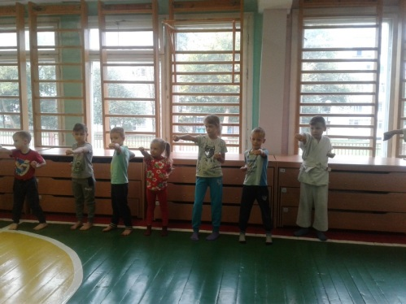 | 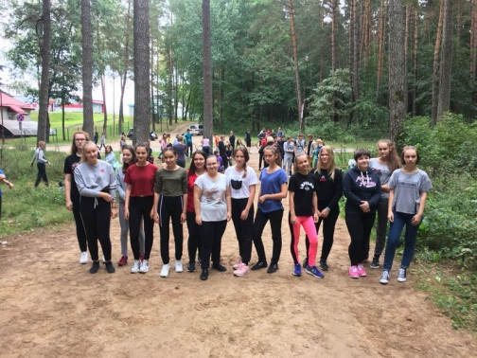 | 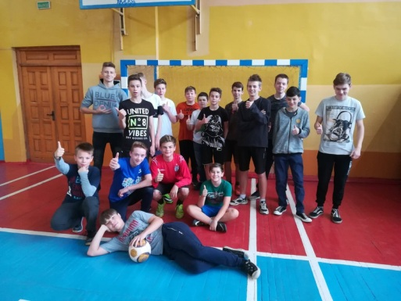

1. Project name: "It is fashionable to be healthy"

(reconstruction of the sports hall for the organization of educational and leisure activities of students).
2. Projectimplementationperiod: 2 years
3. The applicant organization: State Educational Institution "Secondary school №23, Grodno"
4. Project goal: prevention of illegal behavior and family problems through the functioning of a modern sports hall for physical education and sports in the school.
5. Tasks planned for implementation within the project:
- promotion of a healthy lifestyle and prevention of socially negative phenomena in the youth environment (reduction of crimes and administrative offenses committed by children and adolescents);
- creating conditions for additional education of students in sports sections and associations of interests;
- organization of meaningful leisure activities for a wide range of young people and teenagers.
6. Target group:
- school students (800);
- residents of the neighborhood where the school is located (Boldin street, Stroiteley Ave., BLK, Kalinovsky street, Vrublevsky street).
7. Description of the project activities:
- modernization of the school sports hall;
- organization and conduct of educational classes, classes of associations of interests in order to form a healthy lifestyle for students of the school and district;
- promotion of a healthy lifestyle through sports events, competitions and friendly meetings of various levels;
- organization of leisure activities for teenagers.
8. Total funding (in US dollars): 100 000
Sourceoffinancing | Amount of financing  (in US dollars)
Donorfunds | 90 000
Ownfunding | 10 000
9. Project location: 12B Boldina street, Grodno
10. Contact person:
Konyushkevich N. G., Director, tel. / Fax: +375-152-442-142;
e-mail: school23@mail.grodno.by

