Humanitarian project
By Republic Clinical Hospital of Medical Rehabilitation

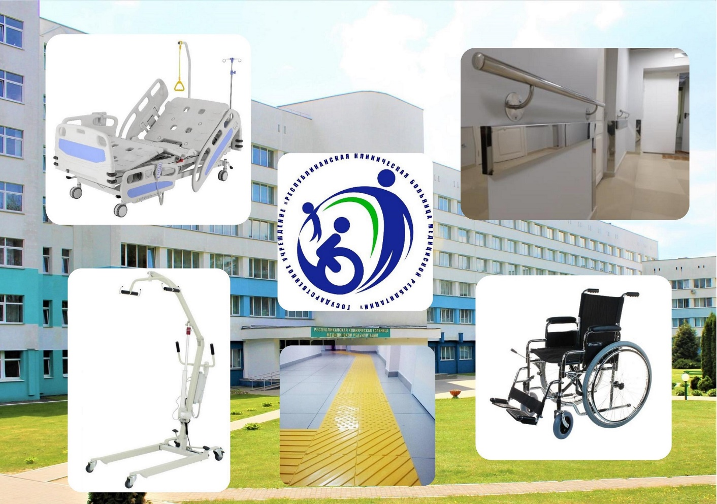

- Project Title: Medical and social rehabilitation of patients with spinal injuries
- Project implementation period: years 2021–2023
- Beneficiary, proposing the project: Public institution “Republic Clinical Hospital of Medical Rehabilitation”
- Project goals: intentions aimed at the rehabilitation of patients with spinal injuries and disfunction of pelvic organs
- Objectives of the project :
-creation of actual “barrier-free” environment for patients with spinal injuries;
-installation of modern equipment in the curative gymnastics facilities;
-procurement of consumables for patients with spinal injuries.
- Target group: patients with spinal injuries and dysfunction of pelvic organs.
- Brief description of project activities:
-renovation of departmental facilities in order to ensure the convenience of hospital stay for patients with spinal injuries;
-creation of actual “barrier-free” environment;
-purchase of medical equipment, training machines
- Cumulative amount of financing (USD) – 300 000 $
Funding source  Republican budget | Finance amount  (USD) – 300 000 $
Donor funds | 250 000 $
Co-financing | 50 000 $
- Place of project execution: Republic of Belarus, 223032, Minsk region, v.Aksakovschina, Rechnaia str. 1
- Contact person: Malyshkа Siarhei, Chief doctor of the Public institution “Republic Clinical Hospital of Medical Rehabilitation”, +37517 509 73 01

