**Humanitarian project**

**state institution «Soligorsky district territorial center for social services of the population»**

**«Life without barriers»**

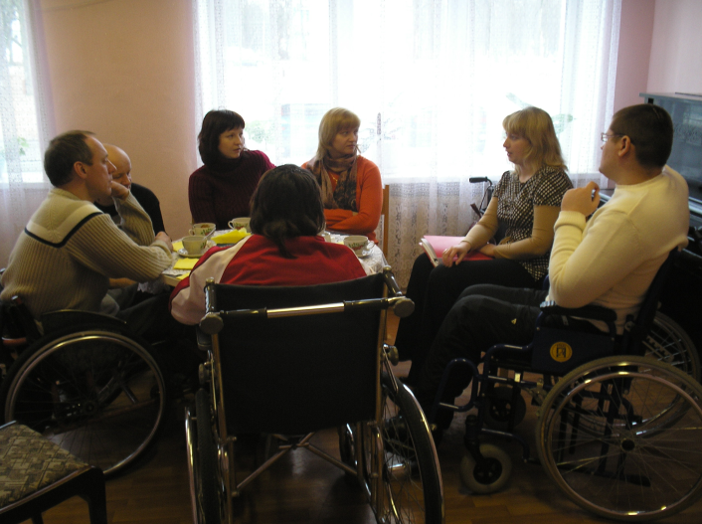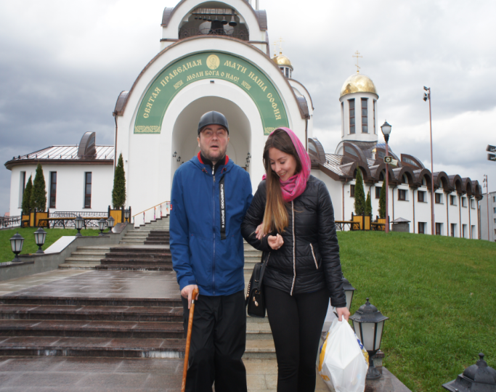

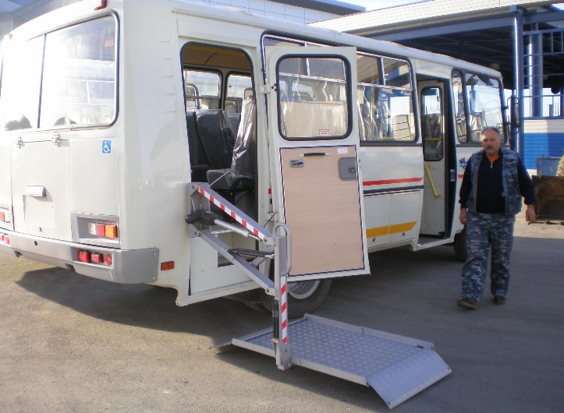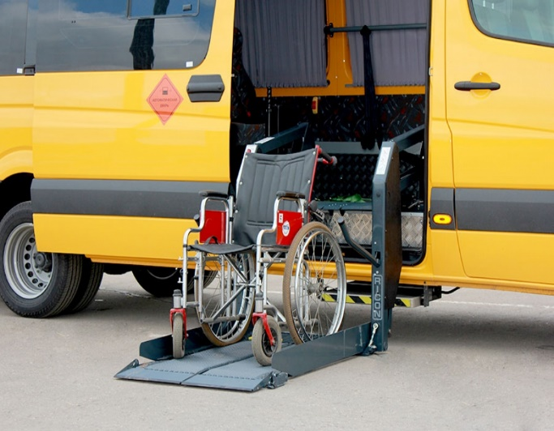

1. Name of the project: "Life without barriers"

2. Realization term: 1 year

3. The organization applicant offering the project: GU “Soligorsk regional territorial center of social services for the population”.

4. Project purposes: improvement of quality of life of physically disabled people, creation of equal opportunities for all and everyone.

5. The tasks planned to performance within implementation of the project:

- the organization and ensuring transportation of physically disabled people to objects of social infrastructure;

- socialization and integration of physically disabled people into society, creation of equal opportunities;

- to contribute to the development of the tolerant relation in society to physically disabled people.

6. Target group: disabled people with musculoskeletal disorders, disabled people with visual impairments living in the territory of Soligorsk region

7. The short description of actions within the project:

- acquisition of the minibus and installation of the elevator;

- the organization and ensuring process of transportation of physically disabled people to objects of social infrastructure, for participation in regional cultural and leisure actions, in festivals of creativity of regional and republican level;

- informing the population of the Soligorsk district through media about provision of services of transportation of people with the opportunities limited physical to objects of social infrastructure.

8. The total amount of financing (in US dollars): 71 500

Financing source the Amount of financing (in US dollars)

Means of the donor 65 000

Joint financing 6 500

9. Place of implementation of the project: Minsk region, Soligorsk, Kozlov St., 8

10. Contact person: Karpovich Veronika Valentinovna, director,

phone number: 80174234263, e-mail: [tsoid@yandex.ru](mailto:tsoid@yandex.ru)

**We will be glad to cooperation!**