Humanitarian project of education department of Pruzhany district executive committee of Brest region is looking for sponsors

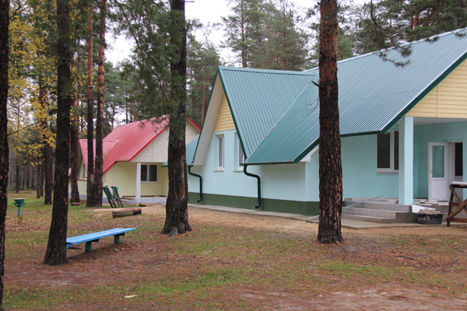
- Name of the project: Children’s summer camp «Dubok» modernization

2. Project implementation period: 18 months

3. Organization, which offers a project: Department on Education of Pruzhany District Executive Committee

4. Aim of the project: wellness management and health support of Pruzhany district children of different categories on the basis of children’s summer camp «Dubok»

5. Tasks to be realized while the project implementation:
- replanning of bedrooms,
- roof covering replacement;
- windows and doors replacement;
- sanitary conveniences construction;
- interior finishing;
- repairing the elevation of the buildings.

6. Task group: children at the age of 6-18

7. Brief description of the events within the framework of the project:
Full repair with elements of two bedroom buildings modernization in children’s summer camp «Dubok»

8. Total funding (dollars USA): 1 500 000
Source of funding | Amount of financing  (dollars USA)
Contributor | 1 485 000
Co-financing | 15 000
9. Place of the project implementation (region/district, town): Brest region, Pruzhany district, Poddubno village
10. Contact person:
A.V.Kopyl, Manager in the field of social security of minors rights,
tel.: 801632 93931, е-mail: zn-roo@pruzhany.by

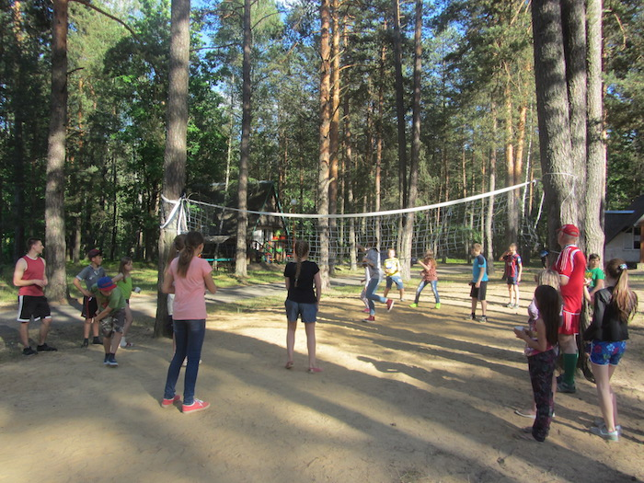

We look forward to collaborating!

