Belarusian Universal Commodity Exchange (BUCE) is the only commodity exchange in the Republic of Belarus and one of the largest spot exchanges in Eastern Europe. BUCE’s main function is assisting Belarusian companies with sales of their products in foreign markets and helping foreign companies to access the Belarusian market.

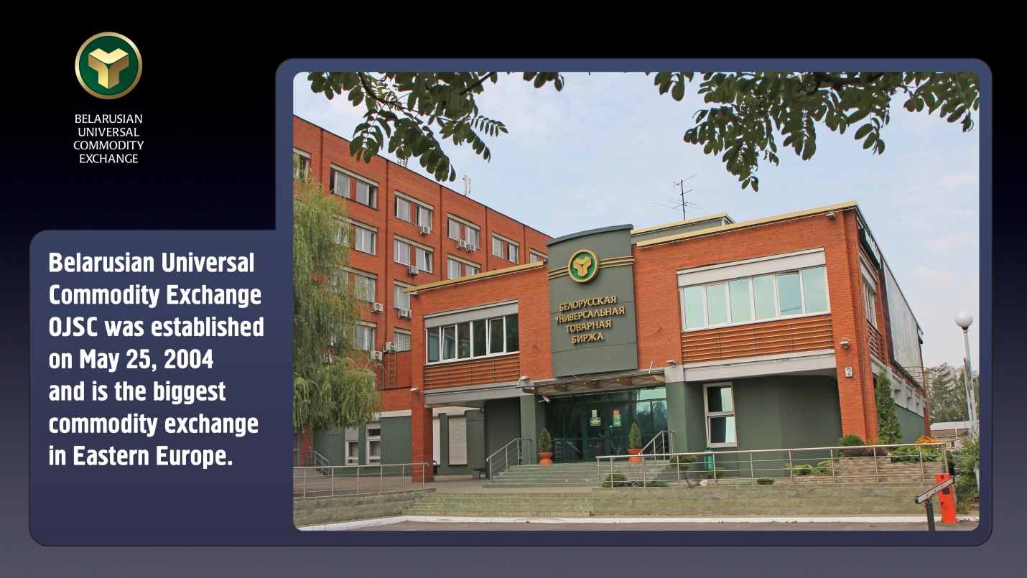

Founded in 2004 BUCE is primarily focused on the spot market – that is when commodities are traded with an expectation of actual delivery, as opposed to a commodity future market when purchased goods are usually not delivered.

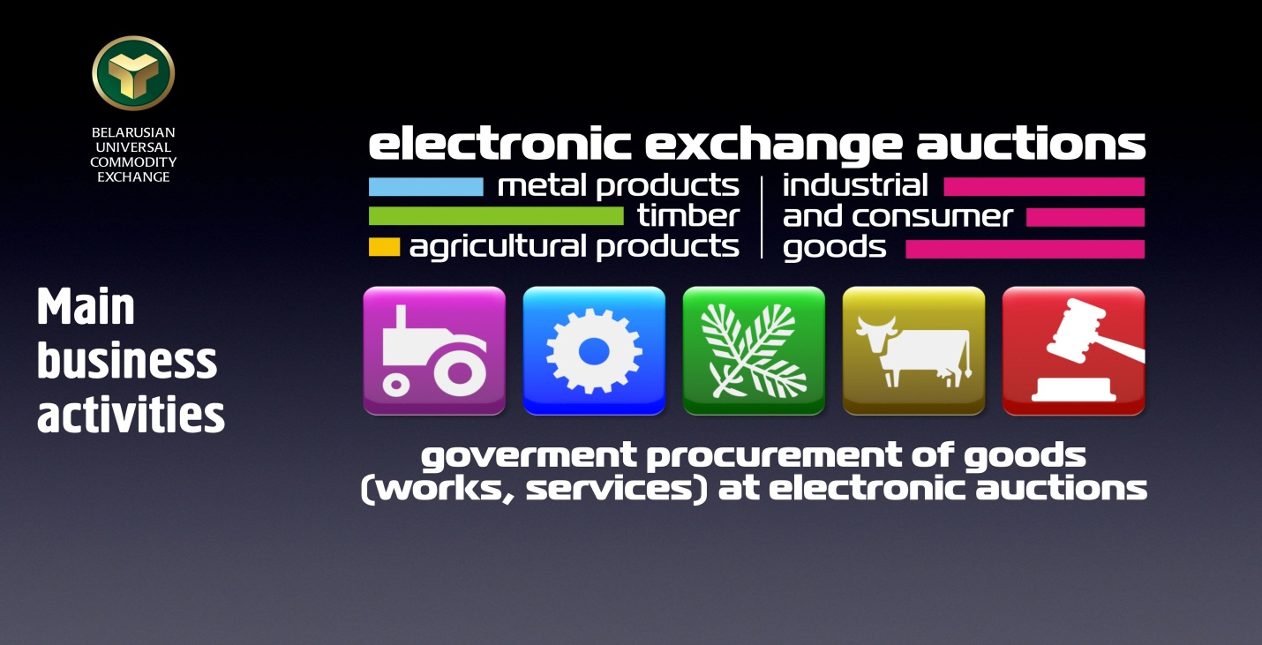

All trading sessions are held by electronic means via Internet, which enables a sustainable growth of exchange turnover, a steady inflow of clients and gradual expansion of the client geography.

Structure-wise BUCE is subdivided into the following sections:

- Metal products. Ferrous metals (over 400 thousand tons a year, 20% of the entire national market), non-ferrous metals (about 20 thousand tons), coal (about 40 thousand tons), coke (in excess of 20 thousand tons), electrical products.
- Agricultural products. Casein, milk powder, butter, cheese, cottage cheese, butter and canola rapeseed, flour, cereals, hides of cattle, cattle meat and pork, sugar, and salt.
- Timber. Pulp wood, saw-timber, plywood, chipboard, fiberboard, and paper.
- Industrial and consumer goods. The electronic subsystem of auctions with industrial and consumer goods works on-line around the clock and allows to sell and buy goods of the widest range from anywhere in the world where there is the Internet, both with the help of a special purpose software or an interface of an Internet browser. A distinctive feature of this trading subsystem is a possibility to place additional textual and graphical information about the product in the application.

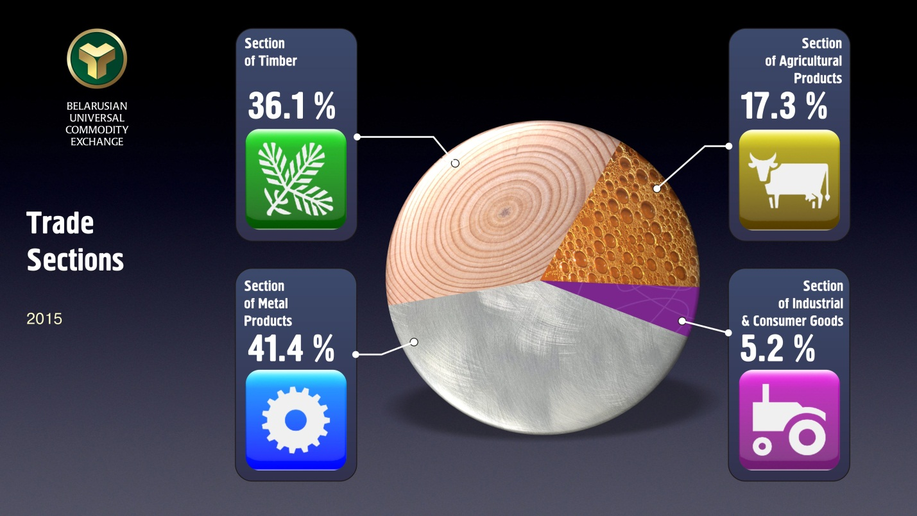

The list of commodities eligible for trading at the exchange encompasses some 3000 commodity items.

BUCE offers logistics services and has a wide network of the exchange warehouses. Thanks to such warehouses any product purchased via the exchange can be collected by the buyer either in his own country or as closely as possible to the desired location. As of yet, foreign exchange warehouses are registered in Russia, Kazakhstan, Ukraine, Poland, Latvia, Lithuania, Estonia, Bulgaria, Belgium, and Germany.

BUCE has branches in all regional centers of the Republic of Belarus and offices in Russia, Lithuania and Latvia.

BUCE is one of two operators of electronic trading platforms (ETP) for electronic auctions under government procurement contracts. Foreign companies that have an electronic digital signature (EDS) issued by BUCE Certifying Authority can participate in government procurements in the Republic of Belarus on the same terms as domestic companies.

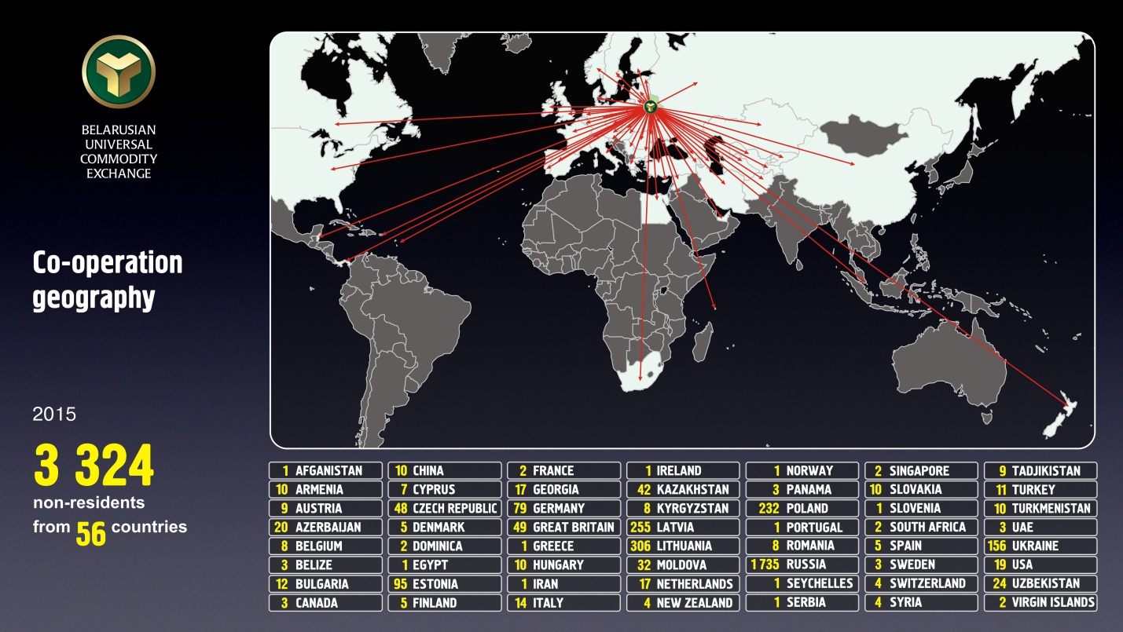

BUCE is a full-fledged member of the following international organizations:
International Association of Exchanges of the Commonwealth of Independent States (since 2008), Inter-exchange Electronic Union (since 2011), Association of Futures Markets (since 2011).

BUCE’s key advantages:
- market pricing;
- wide range of tradable commodities;
- access to thousands of potential buyers and sellers;
- free accreditation;
- ability to conclude multiple transactions within a short period of time;
- complete security of exchange transactions;
- expert examination of exchange commodities;
- transportation and logistics services,
- exchange arbitration.
More detailed information about BUCE and latest statistics can be found here at www.butb.by. Accreditation and EDS issuing procedures are described at www.engl.ecp.by

Contacts:
For further details regarding participation in exchange auctions, please, visit www.butb.by or contact us by telephone: Alexander Bashliy, Head of Foreign Economic Relations: (+375 17) 309-32-88, a.bashliy@butb.by.

