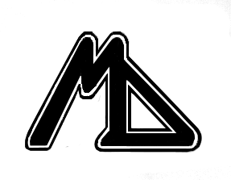  Беларускi вытворча-гандлевы  КАНЦЭРН «БЕЛЛЯСПАПЕРПРОМ»  РЭСПУБЛIКАНСКАЕ ВЫТВОРЧАЕ  УНIТАРНАЕ ПРАДПРЫЕМСТВА  «МАЗЫРСКI ДРЭВААПРАЦОУЧЫ  КАМБIНАТ»  (Дзяржаунае прадпрыемства  «Мазырскi ДАК»)  т/ф 8 (0236) 356264, e-mail: info@moz-dok.by  вул. Сацыялiстычная, 120а, 247760, г. Мазыр, Гомельская вобласць, Рэспублiка Беларусь |  | Белорусский производственно-торговый  КОНЦЕРН «БЕЛЛЕСБУМПРОМ»  РЕСПУБЛИКАНСКОЕ ПРОИЗВОДСТВЕННОЕ  УНИТАРНОЕ ПРЕДПРИЯТИЕ  «МОЗЫРСКИЙ ДЕРЕВООБРАБАТЫВАЮЩИЙ КОМБИНАТ»  (Государственное предприятие  «Мозырский ДОК»)  т/ф 8 (0236) 356264, e-mail: info@moz-dok.by  ул. Социалистическая, 120а, 247760, г. Мозырь, Гомельская область, Республика Беларусь

р./с. 3012014273093 в филиале № 317 ОАО «АСБ БЕЛАРУСБАНК», ул. Советская, 130а, г. Мозырь, МФО 151501678
УНН 490617960, ОКПО 296802923000

From _20.08.2013г._№ _21-04/3327  Mozyr | to chief of the organization
Сommercial proposal

State enterprise "Mozyr DOK" производит:
1. Cut soft wood lumber (pine) natural humidity of different quality grade according to Standards of the Republic of Belarus STB -1713-2007 (customs tariff number 4407109300) Product for sale at a commodity exchange.
Lumber is delivered palletized. To make the package stabile all layers of the lumber changed with layers. For fixity of packages ranks of lumber are interleaved with slayings. Packages are tied with tape. Wrapped packages marked according to the All Union State standard. Lumber is delivered by rail and by road on FCA and DAF terms of delivery according to Incoterms 2010.
This material is used for outside construction work and interior finishing: rough arrangement of floors, ceilings, furniture manufacturing, ladders, scaffolds for partitions, etc.

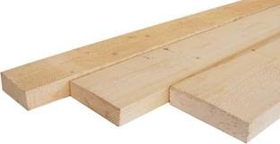
2. Fuel brick (RUF). Fuel bricks are made of dried softwood sawdust. There are no any hazardous substances and bonding materials. Bricks are compressed under high pressure and at high temperature, are rectangular in shape (RUF-briquettes). Briquettes are widely used and can be used for all types of furnaces, boilers for central heating etc., good for fireplaces, stoves, grills, etc. The big advantage of briquettes is the constant temperature combustion for 4 hours.
A positive aspect of the use of fuel bricks is its minimal impact on the environment compared to classic solid fuel with the same calorific value such as coal, it contains 15 times less ash (max 1.0%).
Characteristics of fuel briquettes: moisture - 4.1%, calorific value - 4410-4740 kcal / kg, ash - 0.7%.
Sale of this product is carried out by the execution of the contract. The price of this product is installed on the day of the sale on the FCA terms of delivery according to Incoterms 2010
Goods delivered by road on expendable pallet. Each plastic container consists of 12 briquettes. Stacked on a pallet covered with packing tape and pull the polypropylene tape that sealed with metal straps. Also available in big bags.

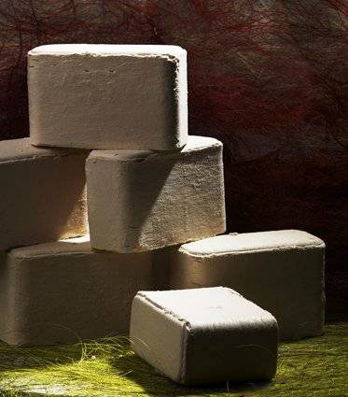

3. chip fuel - milled wood raw material, that can be used only as fuel. Chips is an effective fuel that produce more heat than wood chocks. Generally consists of pine (possible admixture of birch, aspen, alder)
- granulation (length 5-50mm, thickness no more than 30mm)
- ash value no more than 3%;
- relative moisture 25% - 60% .
- caloricity not less 10200 kJ / kg (moisture 40%);
- radioactivity no more than 300 Bq/ kg
Woody stucture is not standardized (it is formed from the waste generated of logging, sawmill and wood processing).

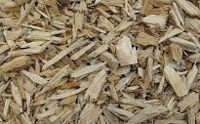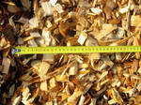

4. Furniture made of solid of oak and birch.State enterprise "Mozyr DOK" produces a wide range of tables and chairs European designed with a high demand among customers in Belarus and abroad.
Furniture is highly reliable and durable, variety of colors, different colors of upholstery. Backs of the chairs have a different bend and shape, so everyone can choose the most convenient variant. To the set of chairs you can select a dining table of the same style.
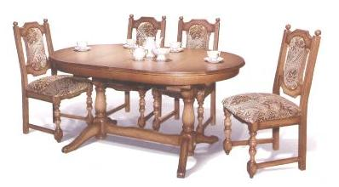
Table MD-415-01
1500(2000)×950×775

Chair MD-57-02
1050×520×500

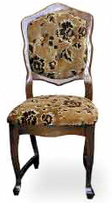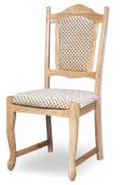
Chair МД-216 Chair МД-59-01

Sale of this product is carried out by the execution of the contract. The price of this product is installed in the contract, according to the price list on FCA terms of delivery according to Incoterms 2010.
Packaging and labeling of goods produced according to All Union State standard. Delivery of furniture is realized by road and rail.

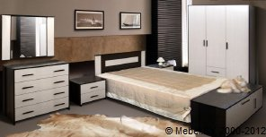

4.1 Furniture for houses and offices. The State enterprise "Mozyr DOK" sells a wide product line of furniture, designed for the improvement of accommodations and offices.
A variety of options and forms of furniture made of laminated chipboard, 16 mm thick, offer the possibility to meet demands of an ordinary man in the street as well as man of business.
The company produces: coffee tables, desks, computer desks, file cabinet and commodes, hall furniture sets, wardrobes and living room furniture sets, beds, children's sets, interior decorations, furniture for residential yard.
All furniture is made from high quality materials with reliable and durable hardware. Affordable price allow the state enterprise "Mozyr DOK" to defy competition for Belarusian furniture manufacturers, and offer their products abroad.
Some of the models of the tables have the ability to transformation for example a small compact coffee tables occupying the limited space transfirm to the large-format tables with variable functions.

coffee table

coffee table MDK -210-01  900х600х570*  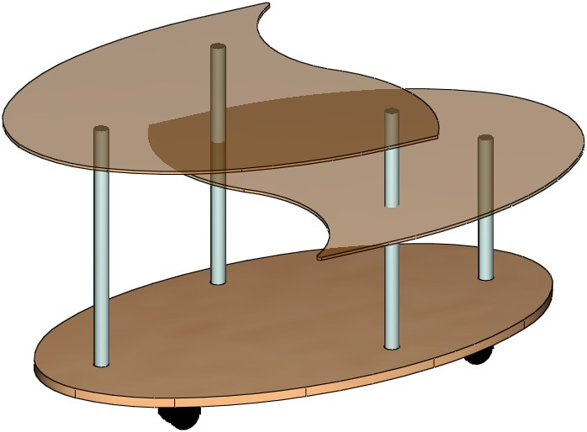 | coffee table MDK -210-06  1005(1580)х645х600*  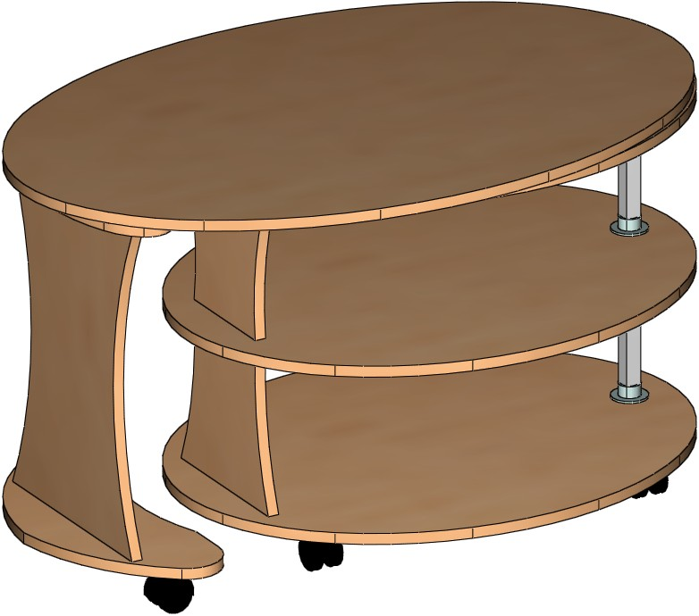
coffee table MDK -217-09  805(1420)х550х560*  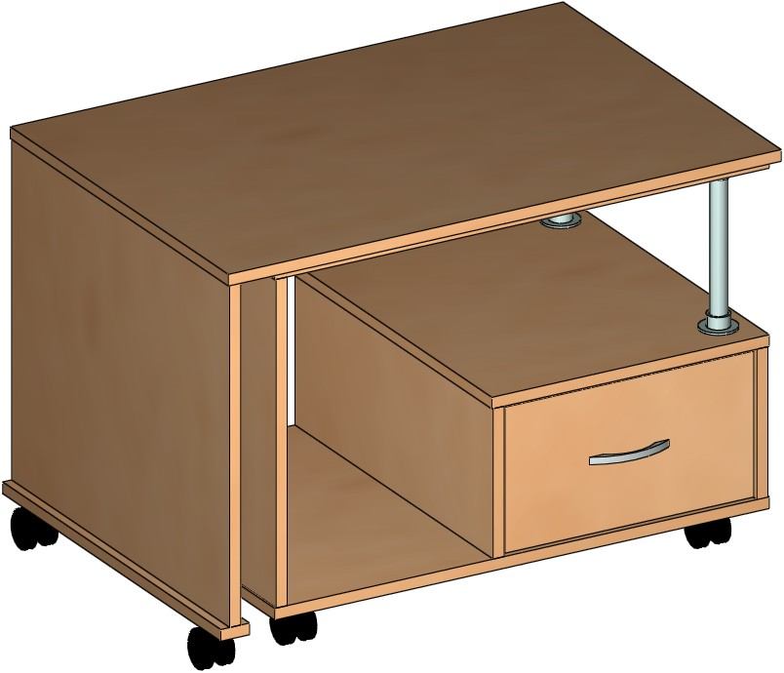 | coffee table MDK -217-08  805(1420)х550х560*  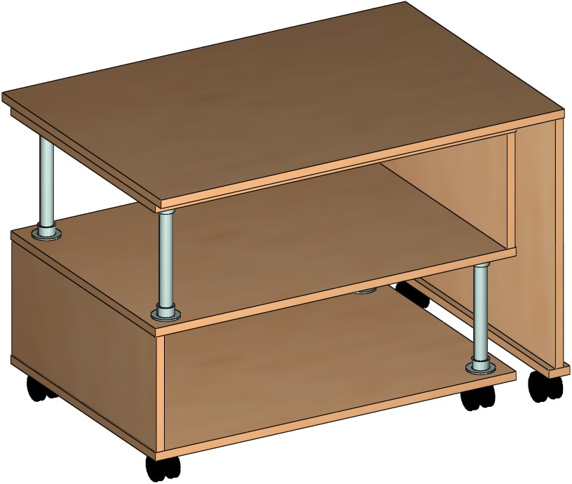

Work desk

Work desk MD -349  1140х576х746 мм  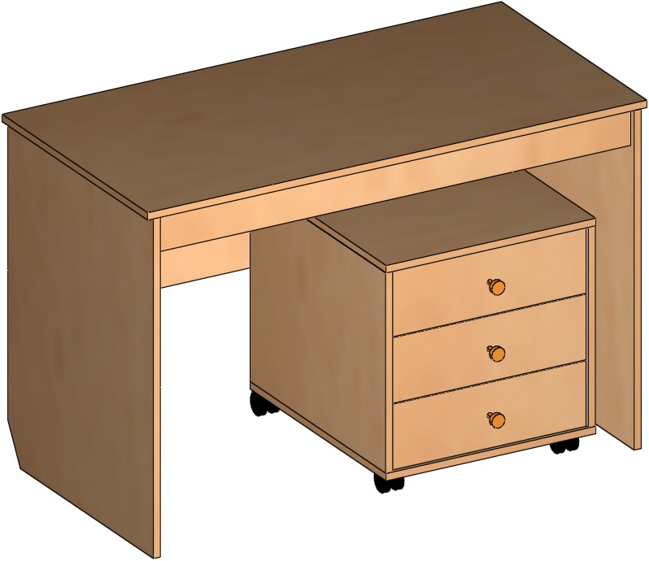 | Work desk MD -350  1382х576х746 мм  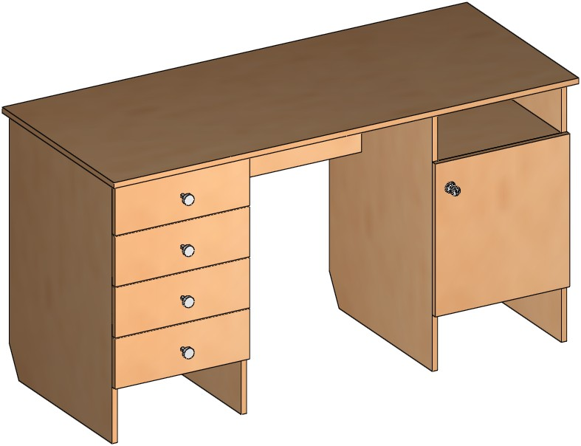
Work desk MD-3491  1140х576х746 мм  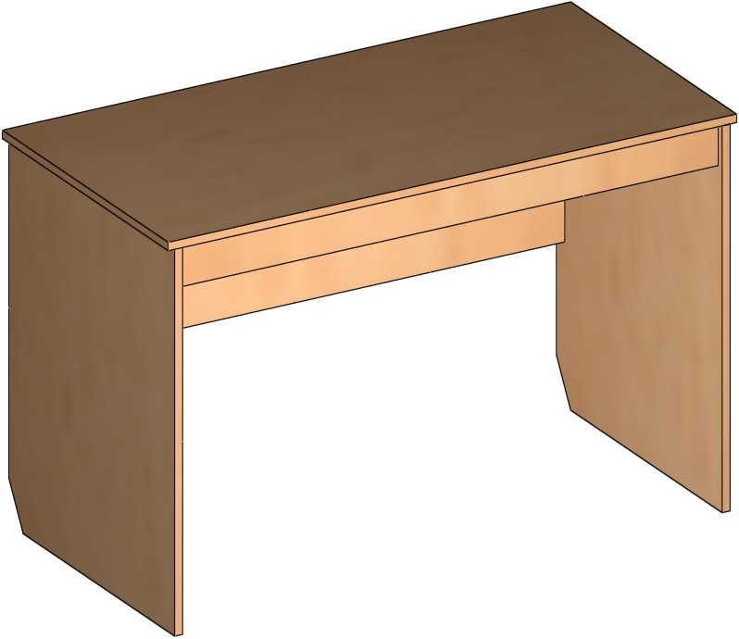 | pedestal-table MDK -30  342(1588)х860х750 мм  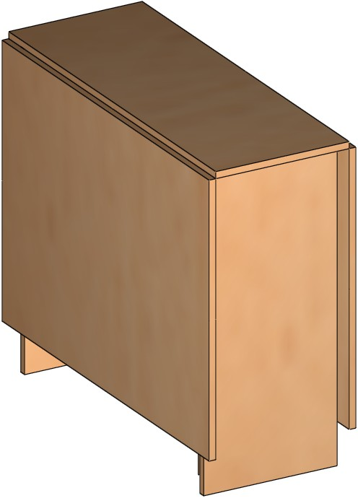

computer desk

computer desk MDK -223  1200х650х1650 mm  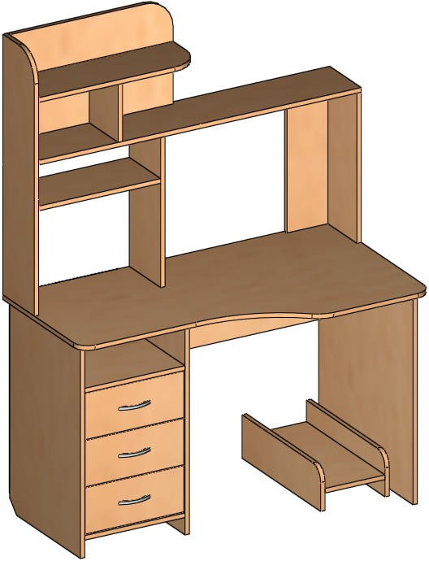 | computer desk MDK -224  1200х750х1900 mm  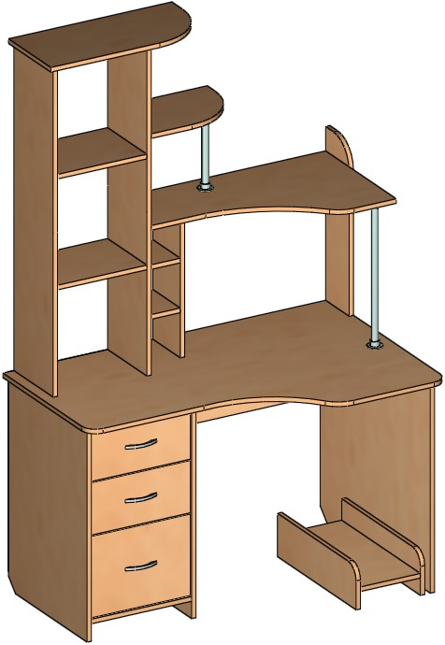
computer desk MDK -225 1600х650х1950mm  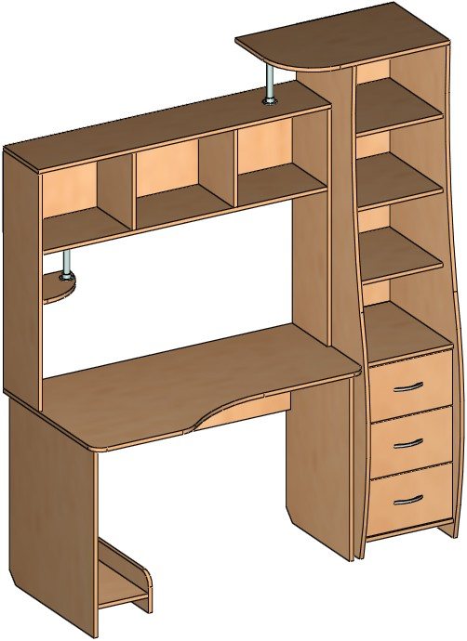 | computer desk MDK -321  800х500х750 mm  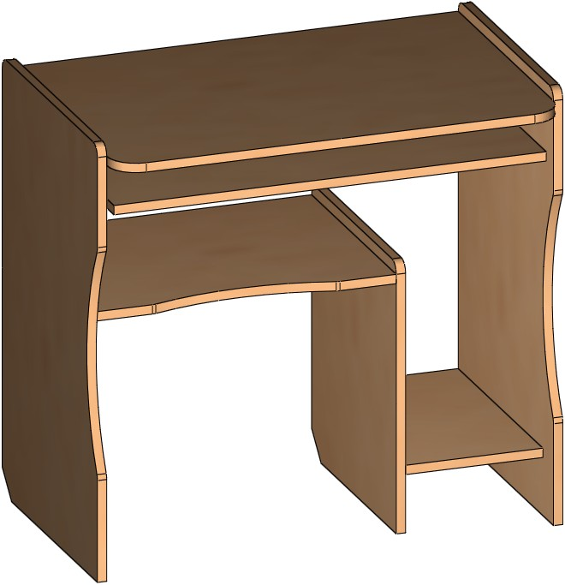
computer desk MDK -226  1697х1310х750 mm  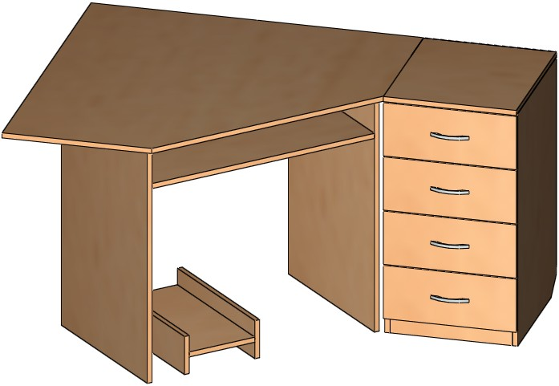 | computer desk MDK -22  1200х600х760 mm  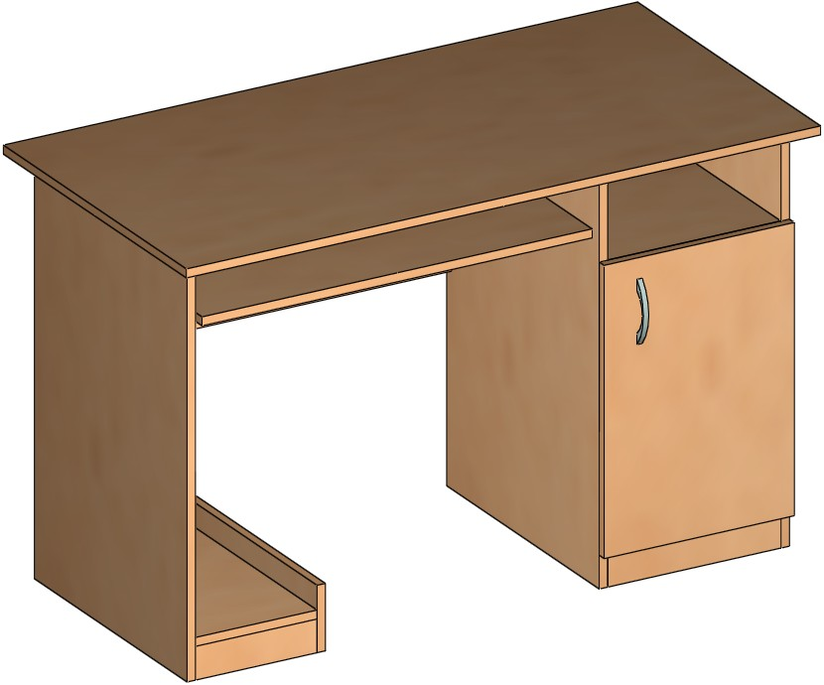

file cabinet and commode

file cabinet MDK -137-05  950х450х860 mm  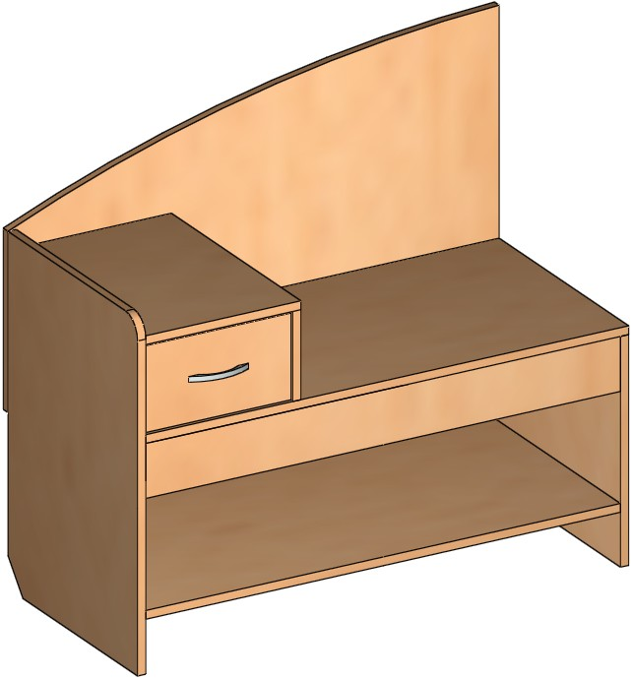 | file cabinet MDK -137-01  950х450х720 mm  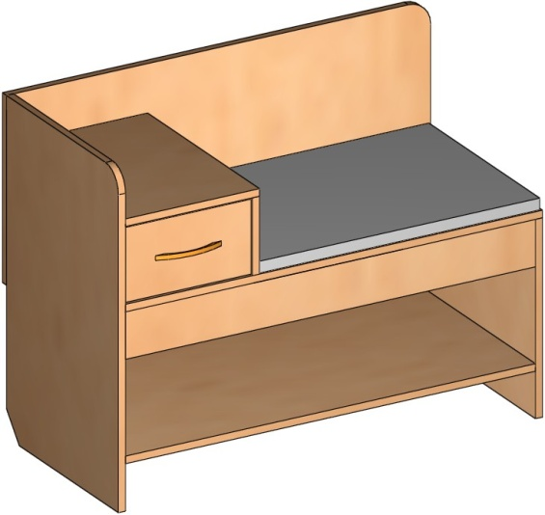
commode MDK -274  950х505х900 mm  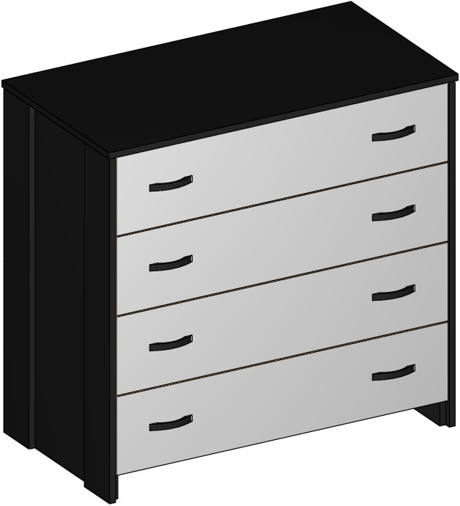 | continental headboard MDK -275-01  610х445х455 mm  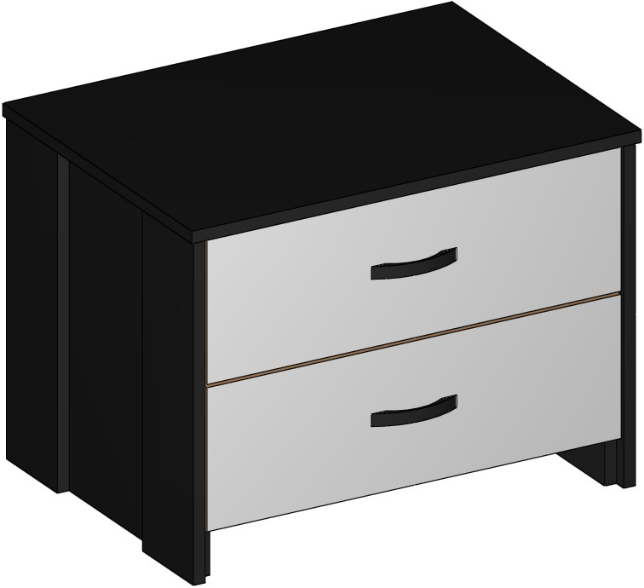
commode MDK -136-03  918х505х700 mm  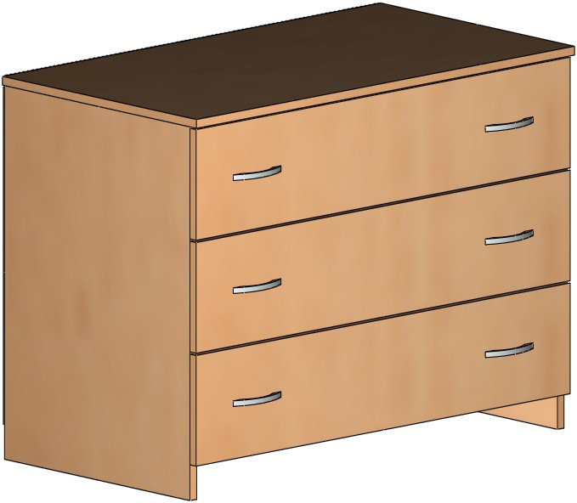 | commode MDK -136-03.2  700х450х791 mm  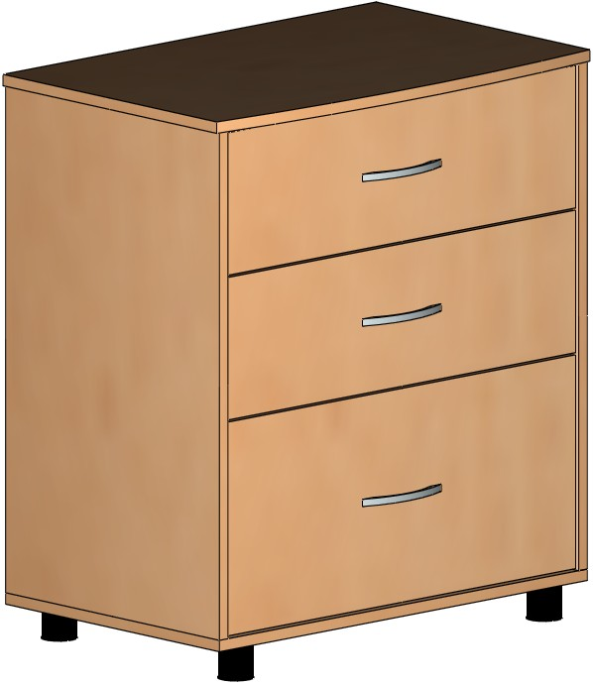

hall furniture set
Fitrobe MDK -141 1710х450х2050 mm  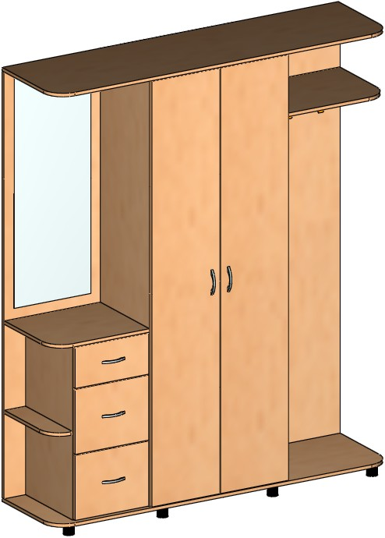 | Fitrobe MDK -141-02 1600х650х2200 mm  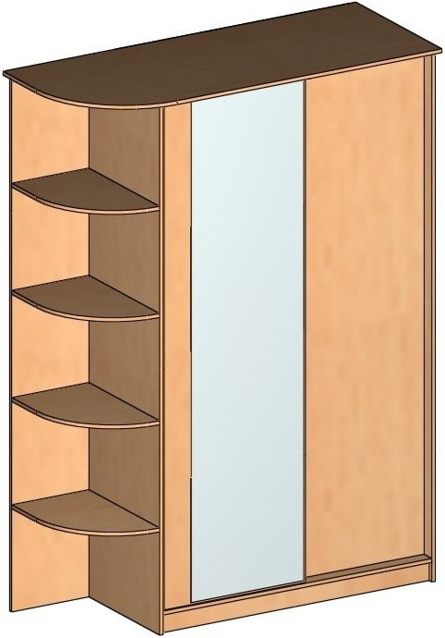
Fitrobe MDK -141-10 1200х400х2050 mm  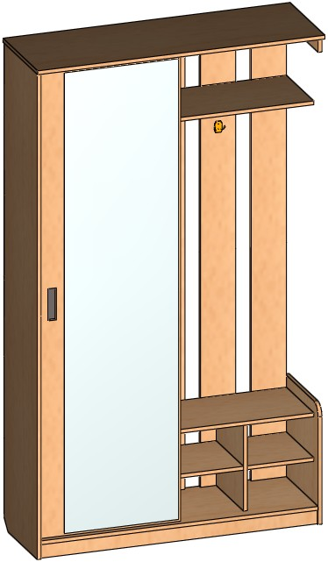 | Fitrobe MDK -141-08 и MDK -141-09  1250х400х2050 mm  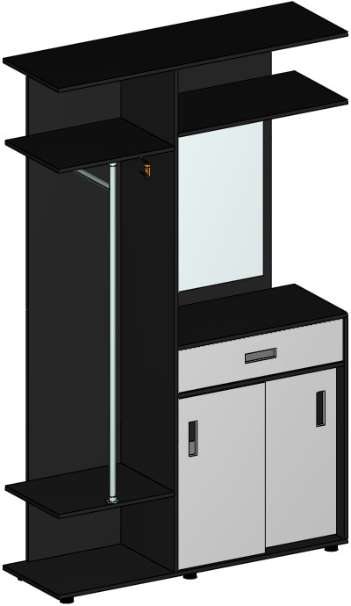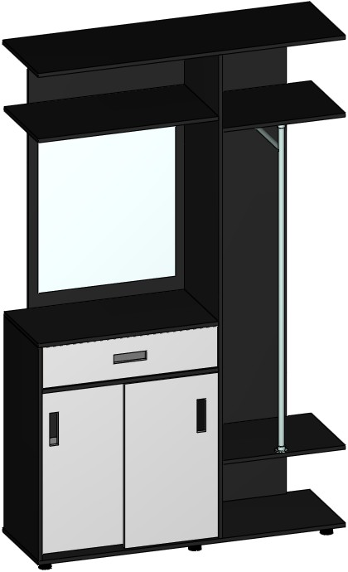

wardrobes and living room furniture set

Wardrobe MDK -272  1828х625х2100 mm  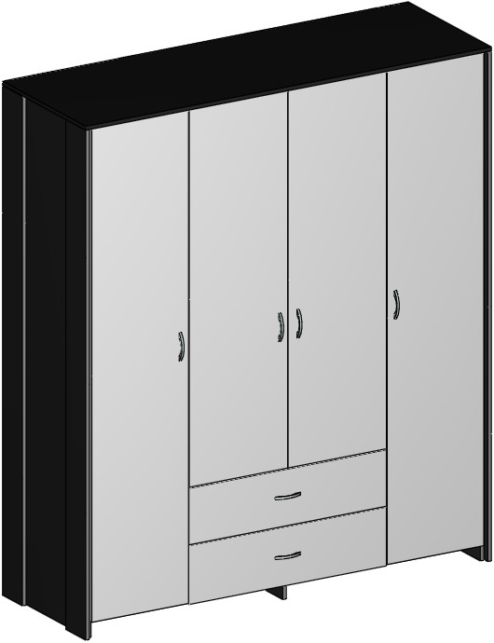 | Wardrobe MDK -61-14  1842х650х2200 mm  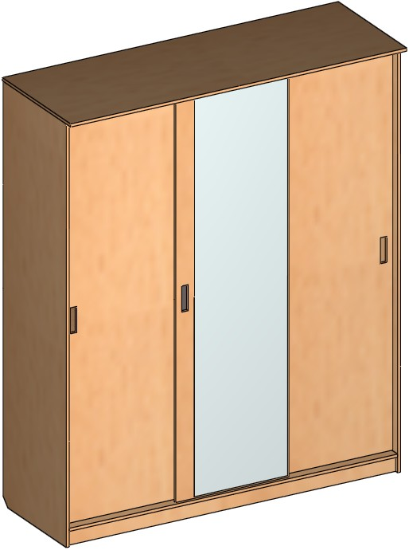
book-caseMDK -35  718х330х1900 mm  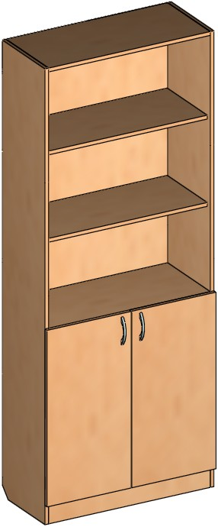 | Cabinet for TV  MDK -137-15  1700х500х1400 mm  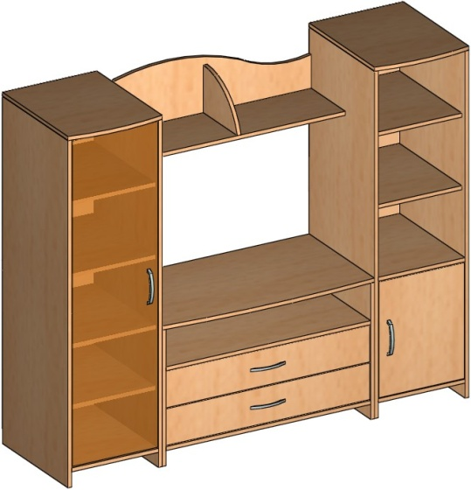

beds
bedstead MDK -273-01  1658х916х2080 mm  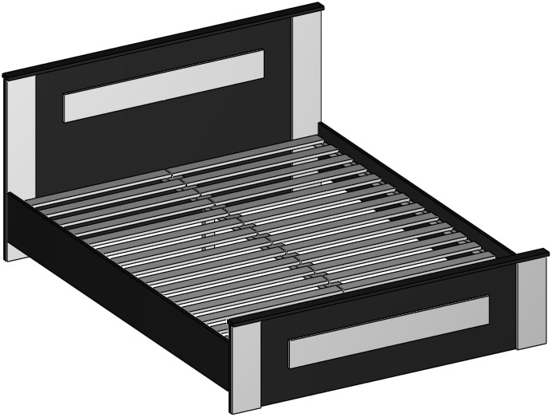 | Bedstead MDK -61-05 1650х916х2050 mm  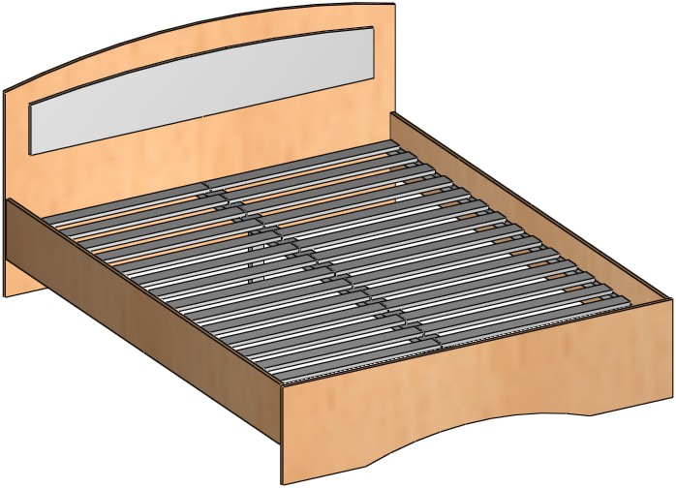
Bedstead MDK -51-01 под матрац 1950х800

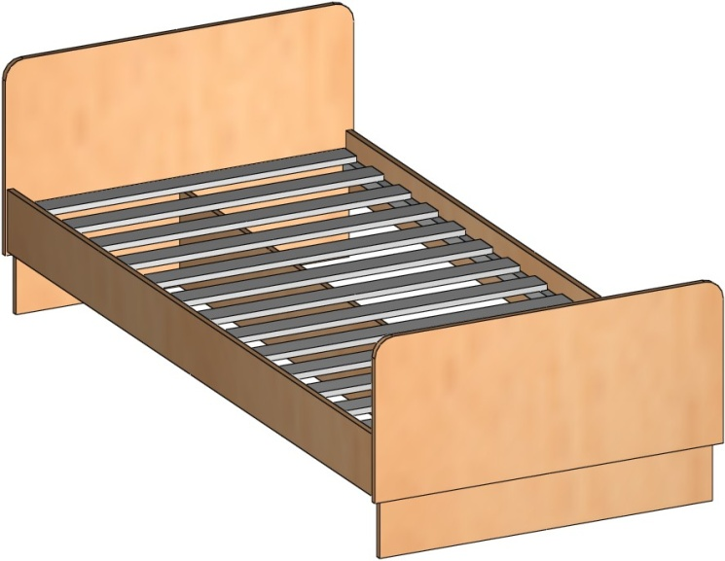

Furniture for playroom

bunk bed MDK -142-02 (без матраца) 2650х880х2150 mm 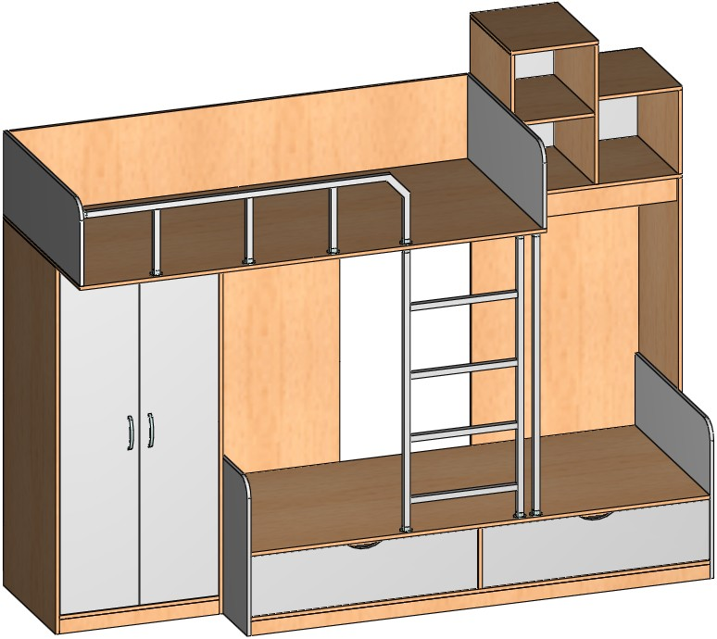 | Bed MDK -142-18  1950х1000х1816 mm 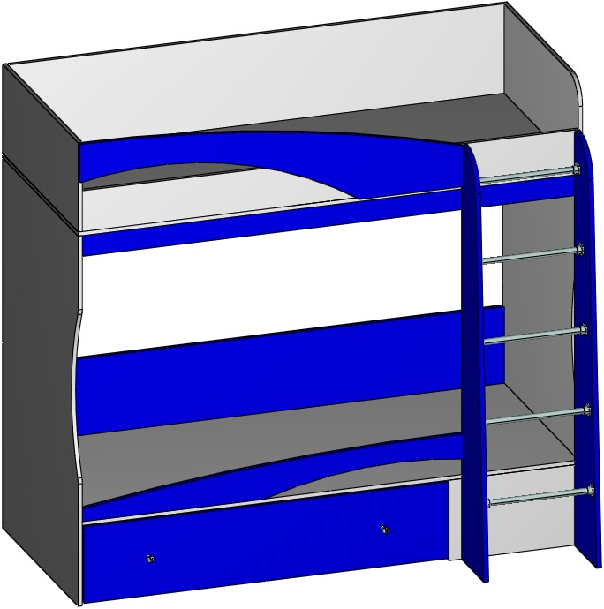

elements of the interior

mirror MDK -277  920х56х832 mm  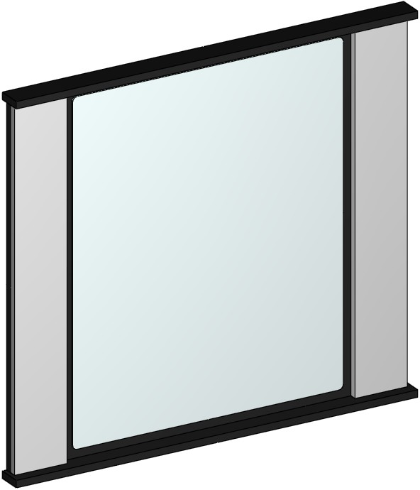 | mirror MDK -61-10 800х900х150 mm  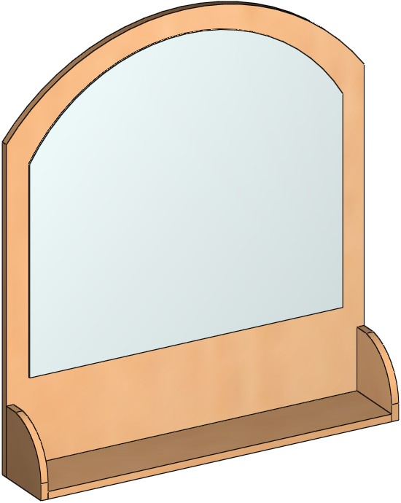
rack MDK -138-04  500х300х1200 mm  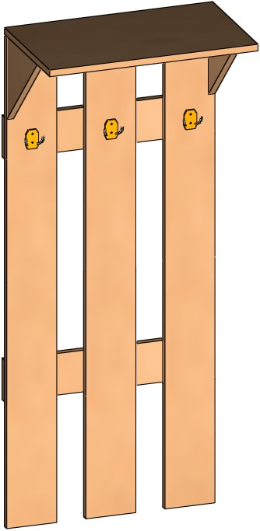 | shelf MDK -142-24 720х250х448 mm  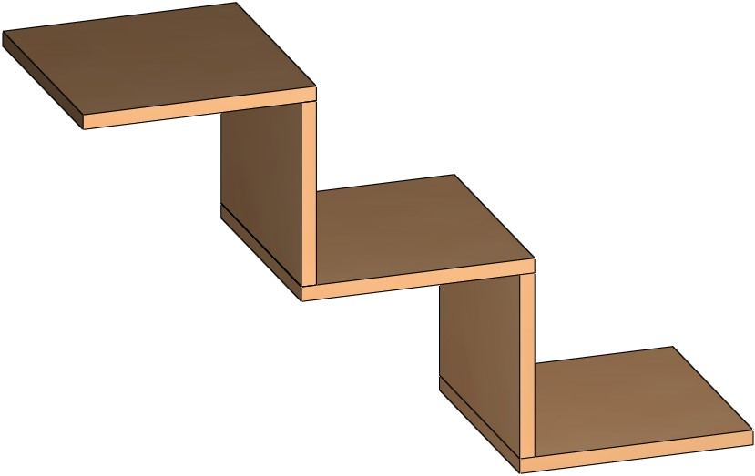  shelf MDK -142-33 478х348х150 mm  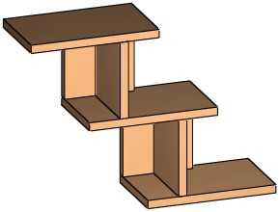
Furniture for residential yard

table MDK -56-02 1000х550х650 mm  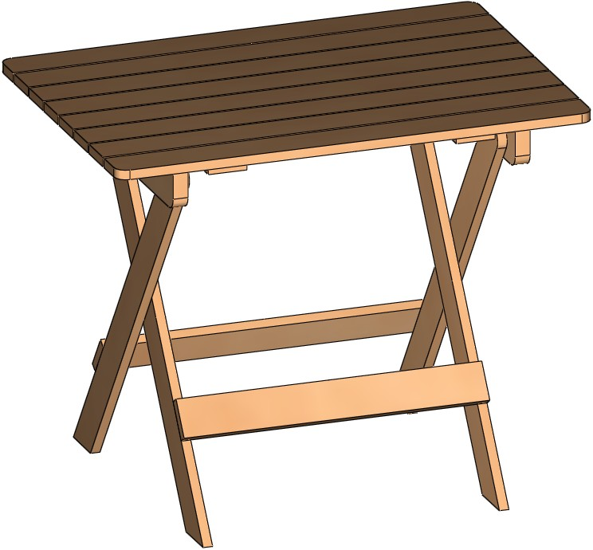 | Chair MDK -56-03 350х350х420 mm  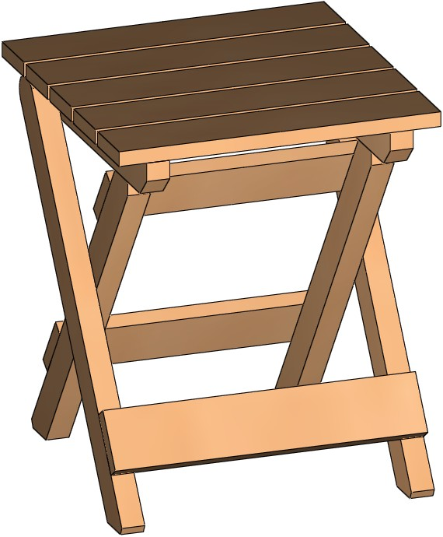
Chair 860х380х330 mm  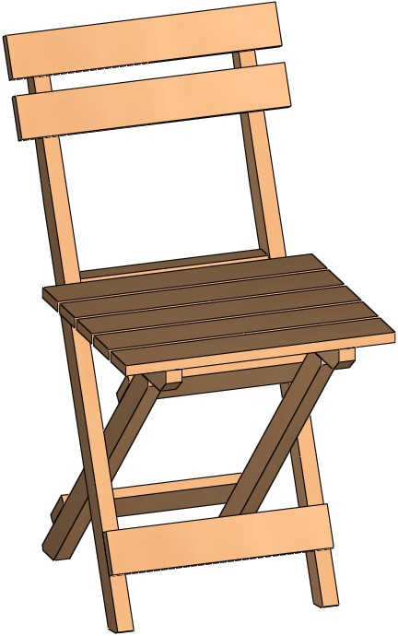 | Box for flowers 350х350х250 mm  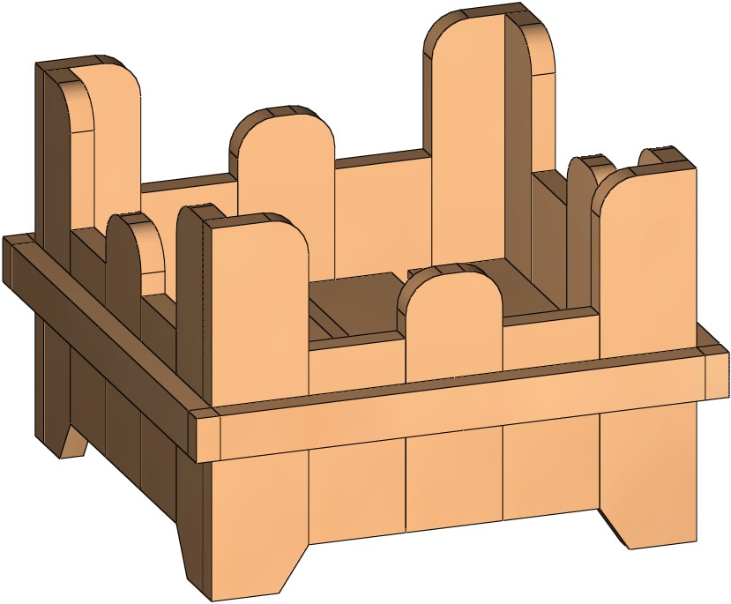  Box for flowers 630х310х200 mm  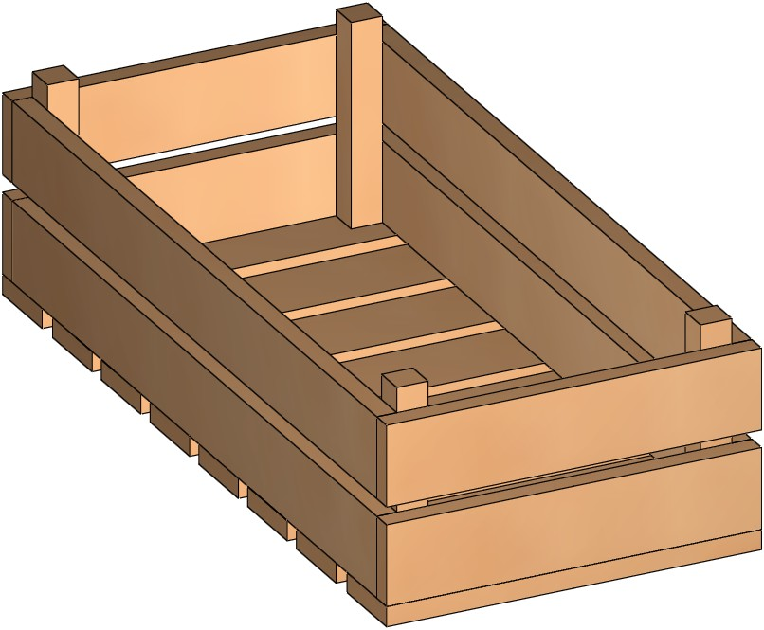
bookcases

bookcase MDK-10-02  747х296х1904 mm  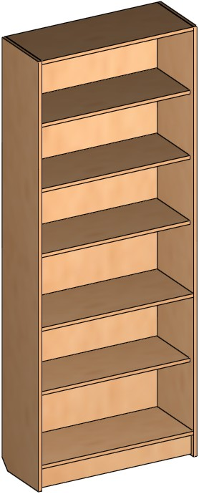 | bookcase MDK -10-06  400х400х1800 mm  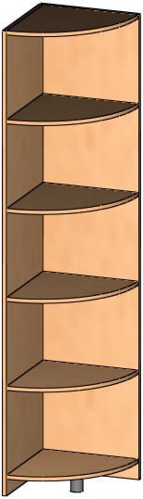
5. Insulating slabs. State enterprise "Mozyr DOK" builds a new plant that will produce heat-insulating slabs from wood-fibered material according to germen technology using germen equipment by “Simpelkamp”, which is planned to start in the 4th quarter 2013
Heat-insulating slabs from wood-fibered material are made of environmentally-green material and can be used for building of new buildings, repairing of external and internal constructions, rebuilding operation with partial or full replacement of old heat insulating and for thermal modernization of the building.
There is no the same plant on the territory of the Former Soviet Republics!
We ask you to consider the application in your production of insulation boards made of wood fiber, the name of which is given below.
Type of the heat-insulating slabs, that will be produced by state enterprise "Mozyr DOK"

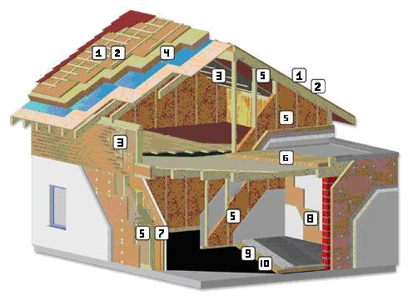
1. BELTERMO - top
2. BELTERMO - ultra
3. BELTERMO - multi
4. BELTERMO - kombi
5. BELTERMO - flex
6. BELTERMO - flat
7. BELTERMO - instal
8. BELTERMO - room
9. BELTERMO - safe
10. BELTERMO - floor

Insulating fibreboard designed for thermal and acoustic insulation Roof-Wall-Coverings, they are made of raw wood of softwood. They are used for protection from the cold in winter, as well as protection from the heat in summer

Application:

heat-insulation of the roof:
- over rafter insulation
- the bottom rafter insulation
- between rafter insulation
heat-insulation of the walls:
- external and internal insulation of the walls
- Materials for external and internal insulation and siding
- internal insulation for repairing
heat-insulation of the floor:
- insulation for the underlayment
- impact noise insulation

- All the heat-insulating slabs, described earlier, have inestimable properties
- High specific thermal rating, in 2,5 time higher in comparison with inorganic material or glass
- absolute safety for humans and the environment, as it does not include synthetic additives and formaldehyde
- inactivity of burning by charring in case of fire
- providing water protection.

Maximum width of insulating fiberboard will be 2.9 m. Thickness of insulating fiberboard 20 - 220 mm. The length of the plate will be made according to customer request.
Coefficient of conductivity varys within limits of 0,039-0,042 W/mK (depends of the type of the slab). Productivity of the new plant will be 321 th. m3 per year.

We are looking for sales representatives in regions of the Russian Federation!
We hope for mutually advantageous co-operation.
You can contact us by e-mail or the contact numbers listed below.

The main principle of the company "Mozyr DOK" - "quality, reliability and affordability of our products!"
Contacts:

vice-manager
Medvedchuk P.I. +375236356600

head of section of Import and Export and marketing
Lapatina V.L. +375236201890
+375292161690
e-mail: info@moz-dok.by
ved.moz-dok@yandex.by

